**Arizona State University  
IFT458**

**Assignment Final Project**

**Student**

Chih-Chieh Chang

**Professor**

Dinesh Sthapit

December 3, 2022

Table of Content

Executive Summary 3

• Github Link 3

User Interface (front end) 4

• Create New User 4

• Log in current User (authentication) 8

• Create new Loans (**Create new flow diagram) 9

• List Loan details (**Create new flow diagram) 13

Middleware: API 17

• Create New User 17

• LogIn Current User (Authentication) 25

• Create New Loans (Protect Resources) 26

• List Loan Details (Protect Resources) 33

Back End: 35

• User Collection 35

• LoanDataBase 38

• LoanCollections 40

Run project screenshot 43

# Executive Summary

In this course, I learn how to create a basic project of javascript and Node.js in module1. Ever since then, I started an amazing journey on web development. The progress in middleware programming is great and unforgettable. ES8 and database design enabled my API to continuously support the website with data.

In the second half of course, I spent a lot of time on authentication and authorization. Professor kept emphasizing the importance of web security and how to validate encryption on data and user password. Every time I was stuck in problems, professor always taught me in patience. The following content is my final project.

## Github Link

# User Interface (front end)

## Create New User

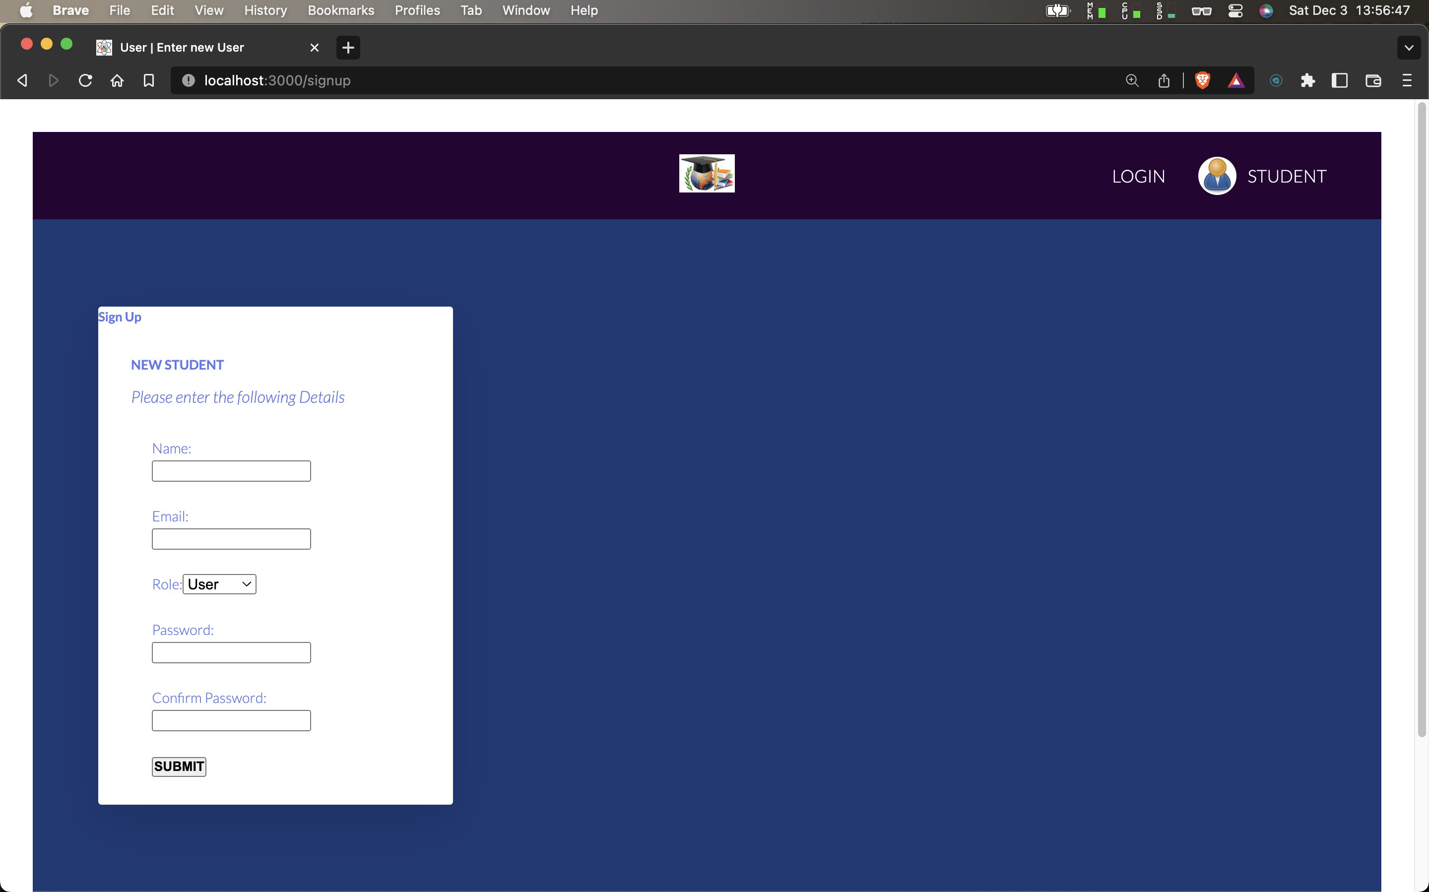

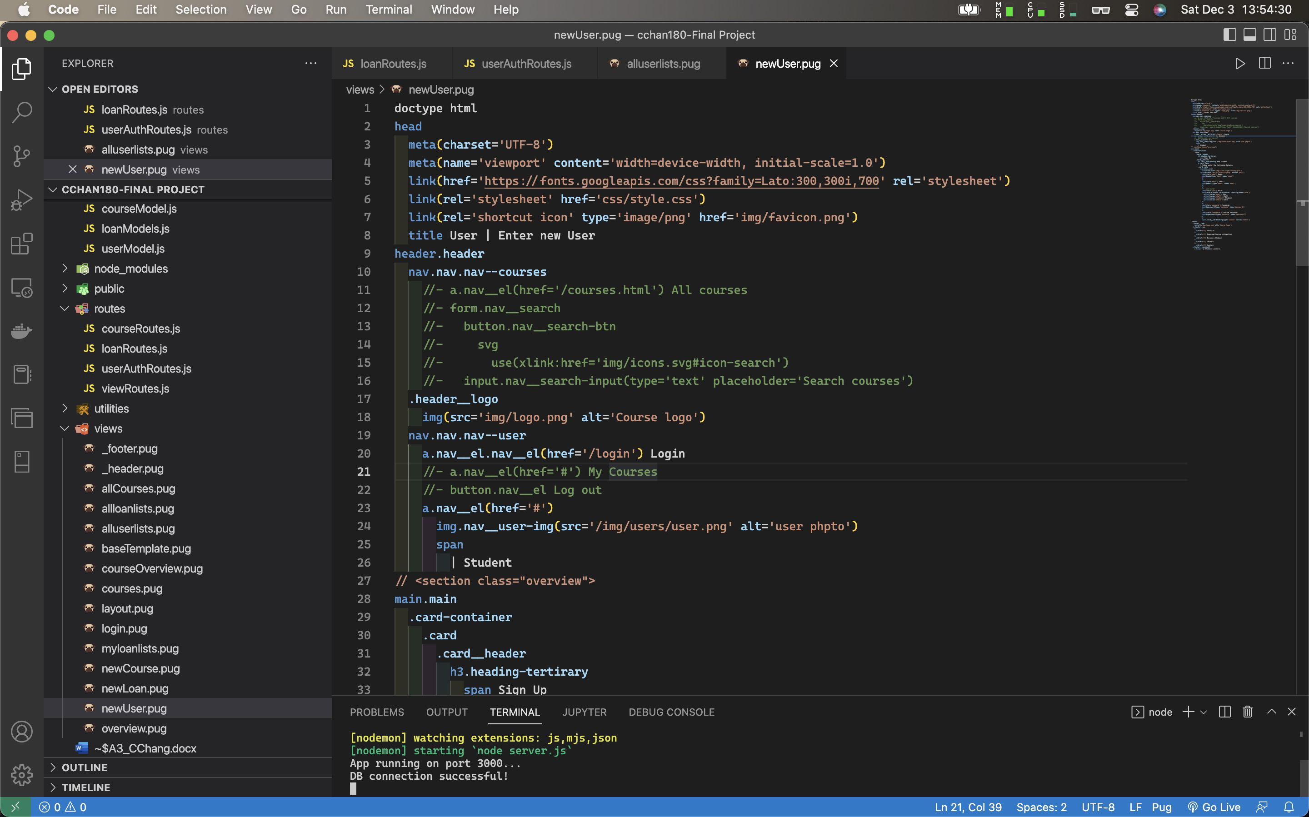

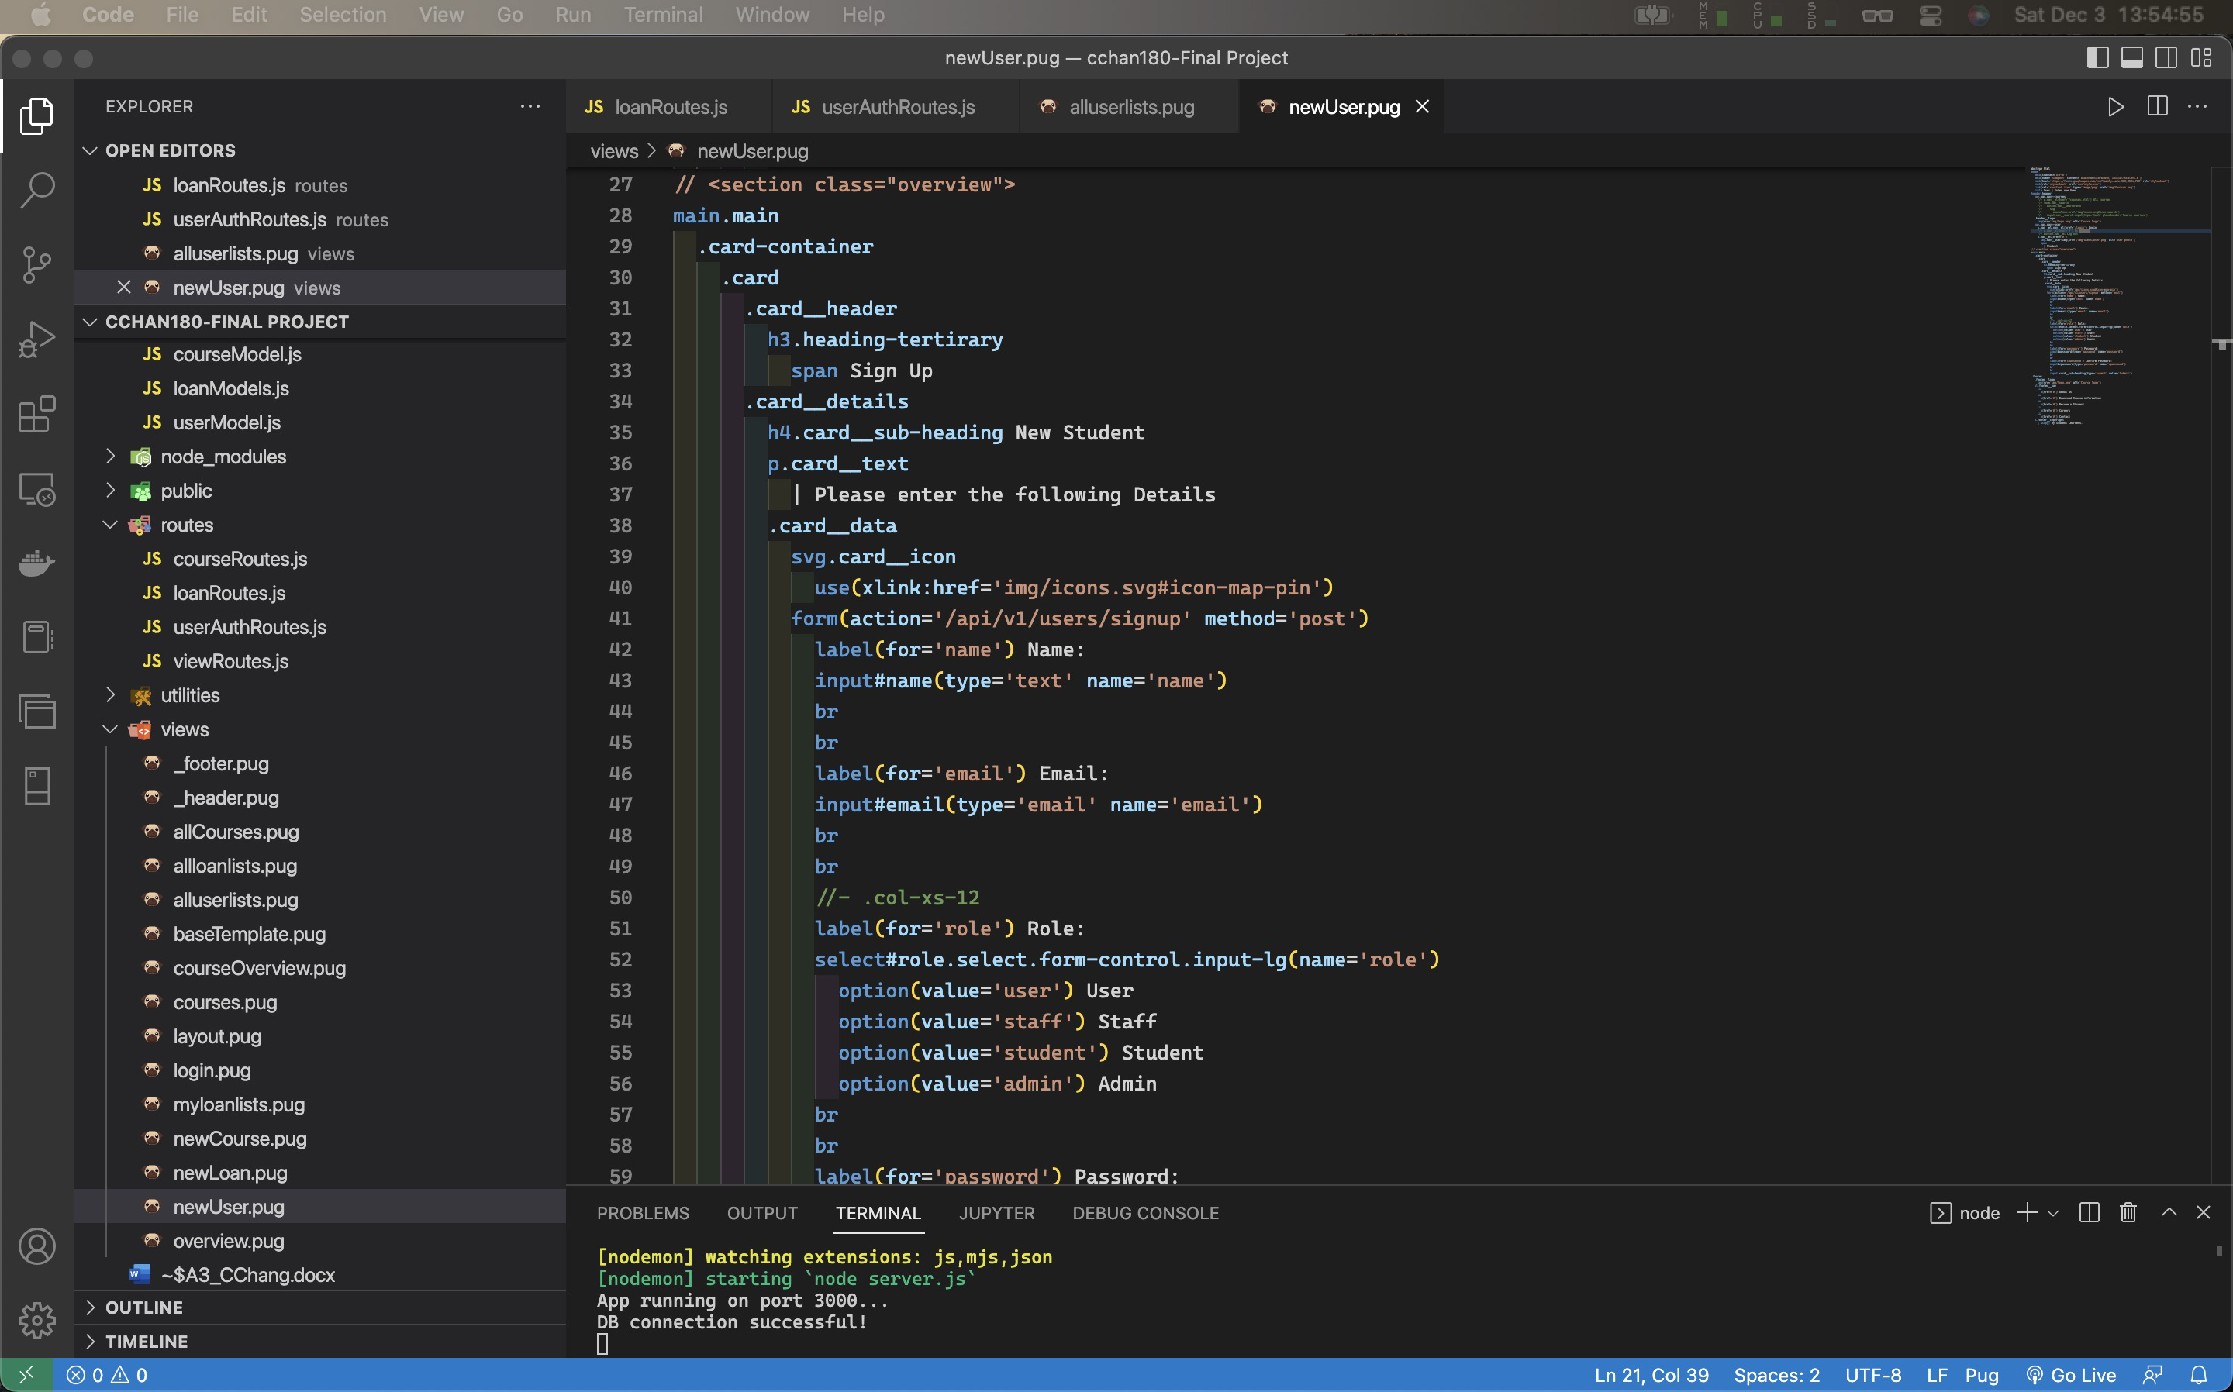

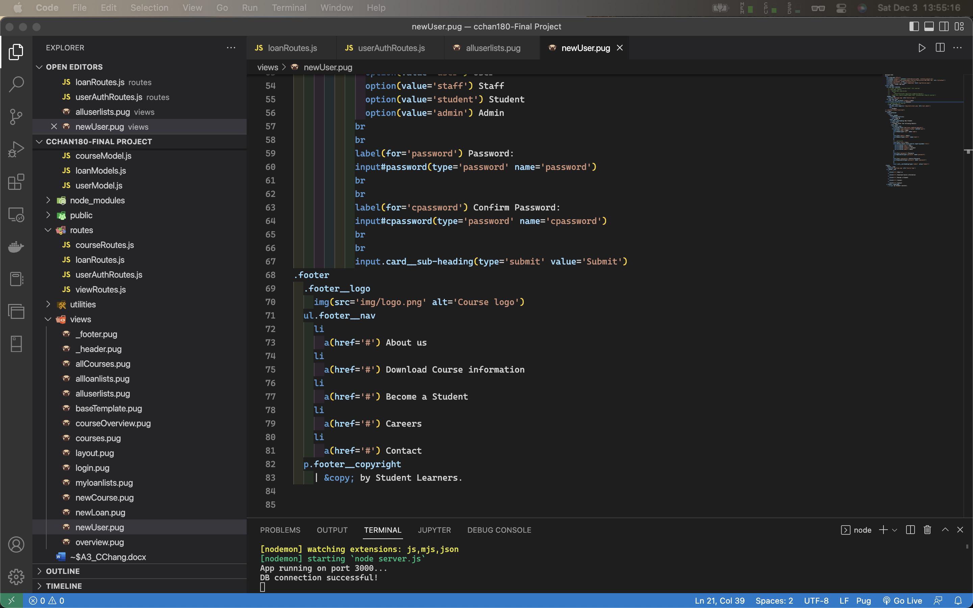

Code of newUser.pug:

doctype html

head

meta(charset='UTF-8')

meta(name='viewport' content='width=device-width, initial-scale=1.0')

link(href='https://fonts.googleapis.com/css?family=Lato:300,300i,700' rel='stylesheet')

link(rel='stylesheet' href='css/style.css')

link(rel='shortcut icon' type='image/png' href='img/favicon.png')

title User | Enter new User

header.header

nav.nav.nav--courses

//- a.nav__el(href='/courses.html') All courses

//- form.nav__search

//- button.nav__search-btn

//- svg

//- use(xlink:href='img/icons.svg#icon-search')

//- input.nav__search-input(type='text' placeholder='Search courses')

.header__logo

img(src='img/logo.png' alt='Course logo')

nav.nav.nav--user

a.nav__el.nav__el(href='/login') Login

//- a.nav__el(href='#') My Courses

//- button.nav__el Log out

a.nav__el(href='#')

img.nav__user-img(src='/img/users/user.png' alt='user phpto')

span

| Student

// <section class="overview">

main.main

.card-container

.card

.card__header

h3.heading-tertirary

span Sign Up

.card__details

h4.card__sub-heading New Student

p.card__text

| Please enter the following Details

.card__data

svg.card__icon

use(xlink:href='img/icons.svg#icon-map-pin')

form(action='/api/v1/users/signup' method='post')

label(for='name') Name:

input#name(type='text' name='name')

br

br

label(for='email') Email:

input#email(type='email' name='email')

br

br

//- .col-xs-12

label(for='role') Role:

select#role.select.form-control.input-lg(name='role')

option(value='user') User

option(value='staff') Staff

option(value='student') Student

option(value='admin') Admin

br

br

label(for='password') Password:

input#password(type='password' name='password')

br

br

label(for='cpassword') Confirm Password:

input#cpassword(type='password' name='cpassword')

br

br

input.card__sub-heading(type='submit' value='Submit')

.footer

.footer__logo

img(src='img/logo.png' alt='Course logo')

ul.footer__nav

li

a(href='#') About us

li

a(href='#') Download Course information

li

a(href='#') Become a Student

li

a(href='#') Careers

li

a(href='#') Contact

p.footer__copyright

| &copy; by Student Learners.

## Log in current User (authentication)

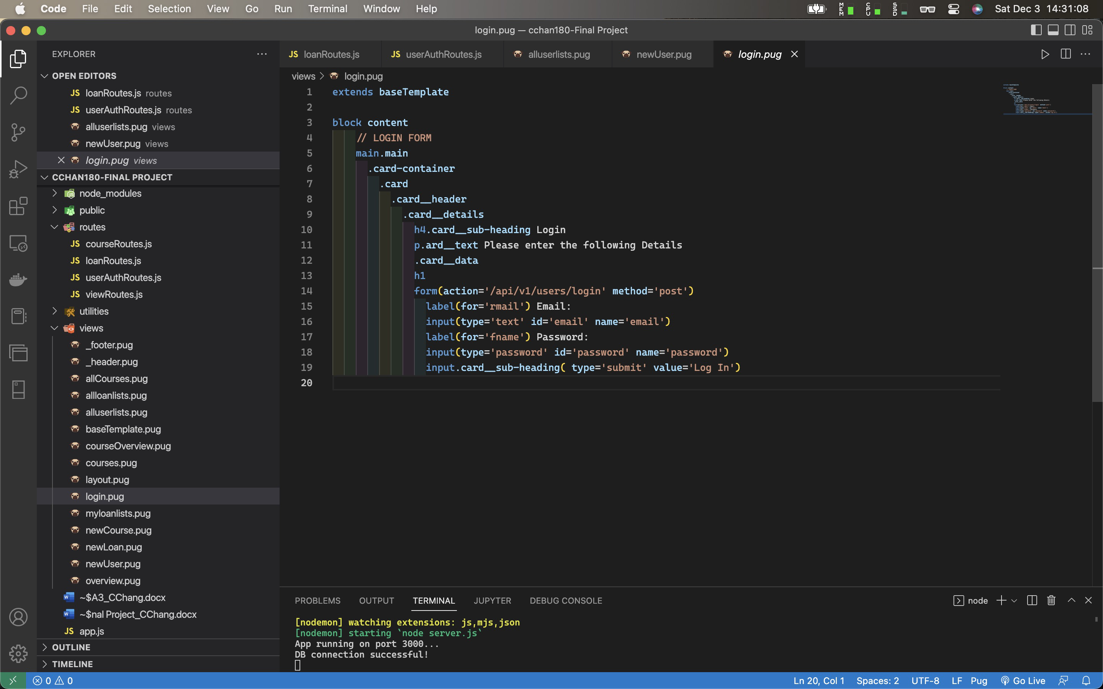

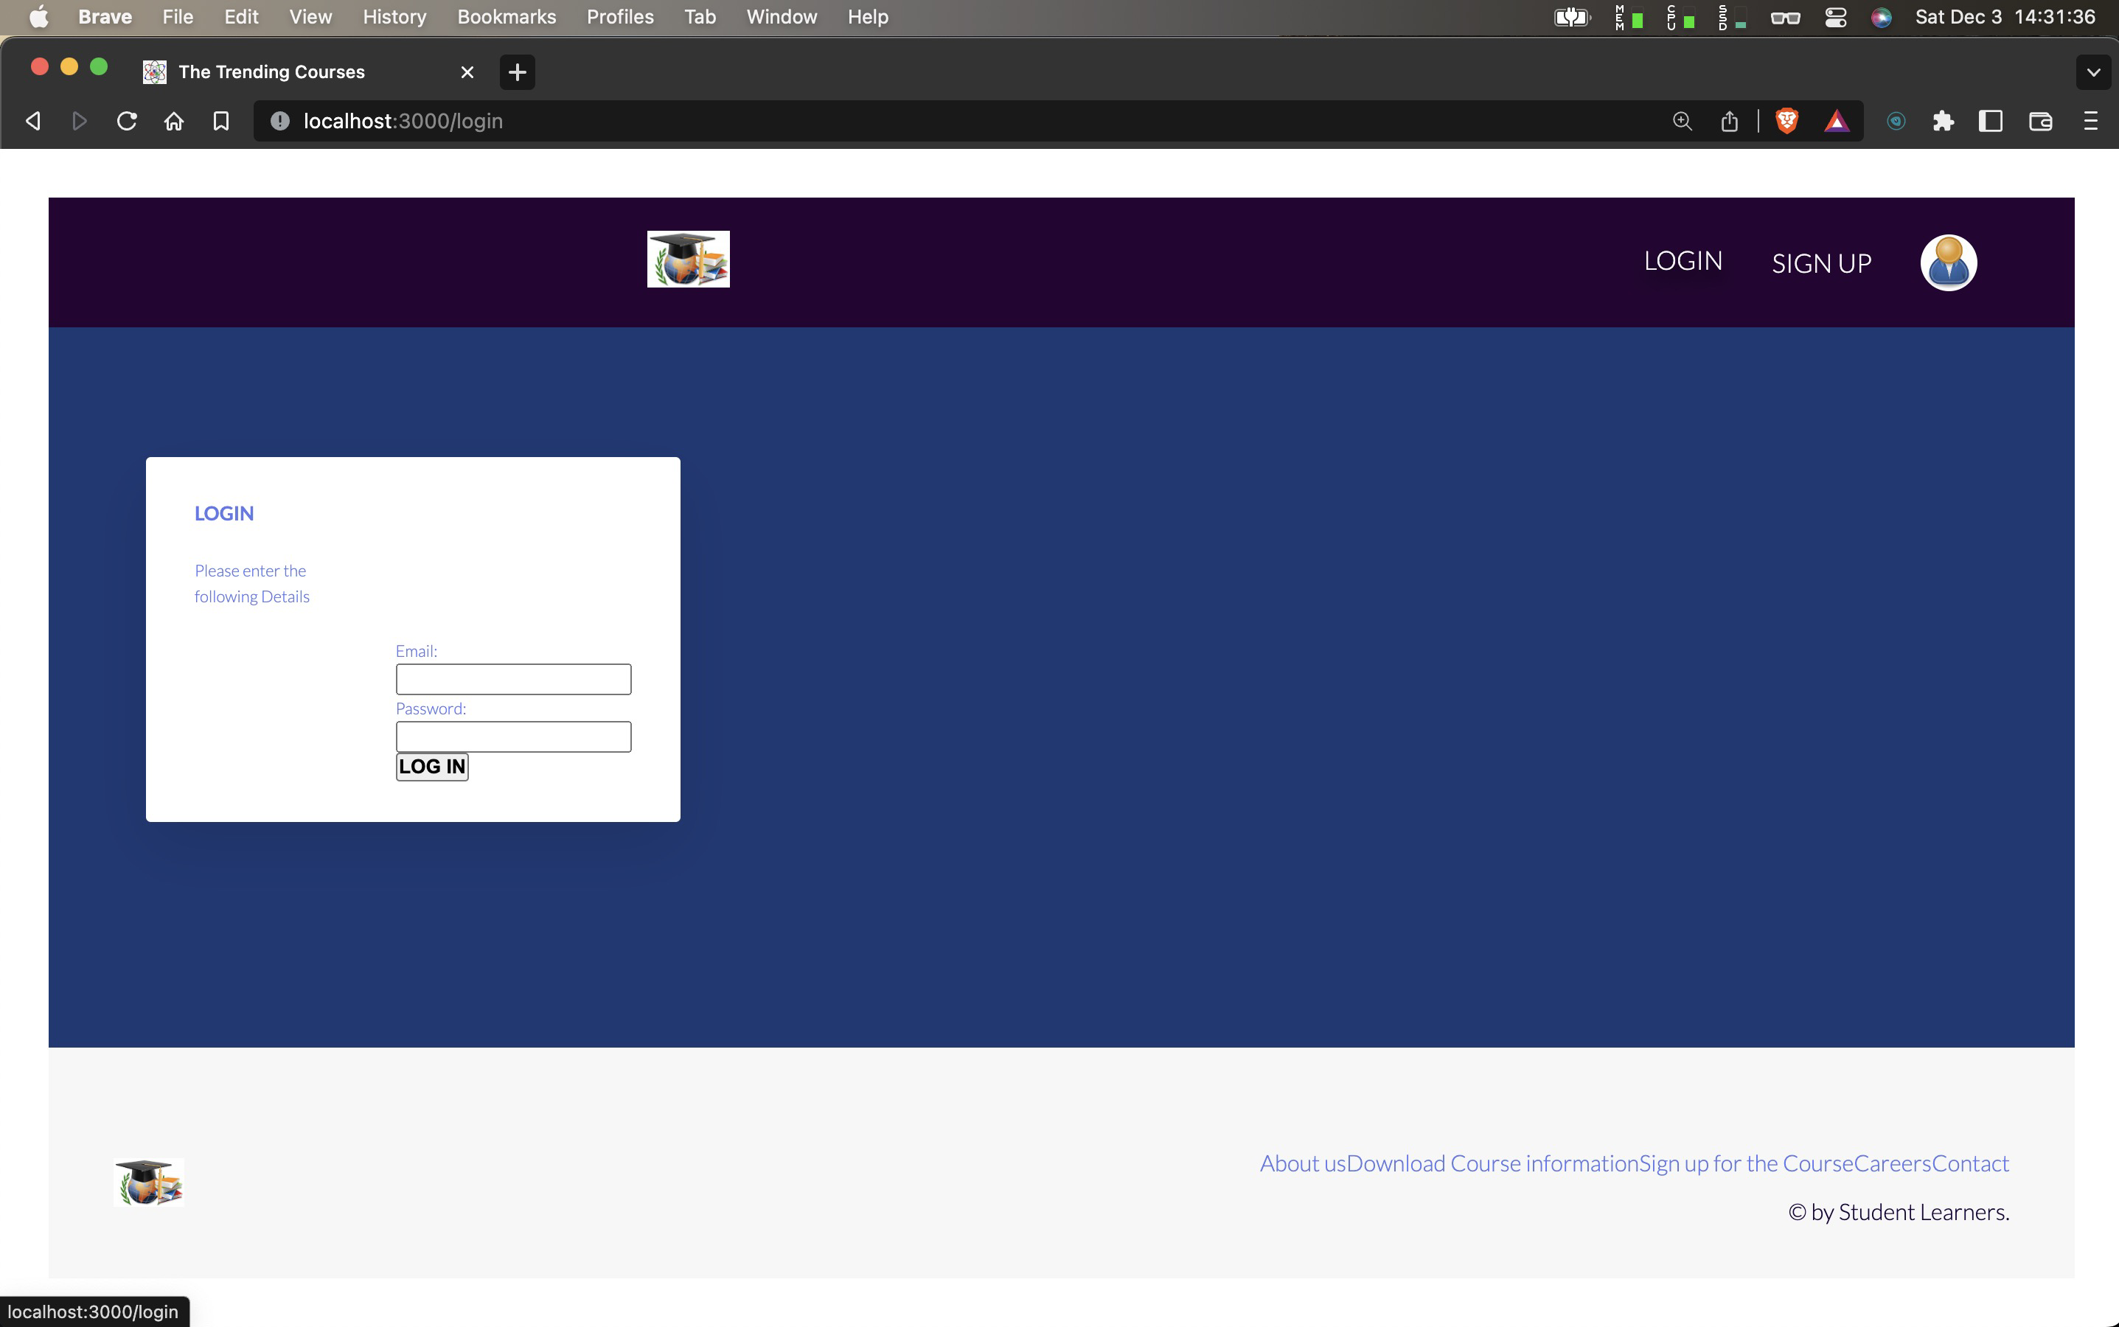

Code of login.pug:

extends baseTemplate

block content

// LOGIN FORM

main.main

.card-container

.card

.card__header

.card__details

h4.card__sub-heading Login

p.ard__text Please enter the following Details

.card__data

h1

form(action='/api/v1/users/login' method='post')

label(for='rmail') Email:

input(type='text' id='email' name='email')

label(for='fname') Password:

input(type='password' id='password' name='password')

input.card__sub-heading( type='submit' value='Log In')

## Create new Loans (**Create new flow diagram)

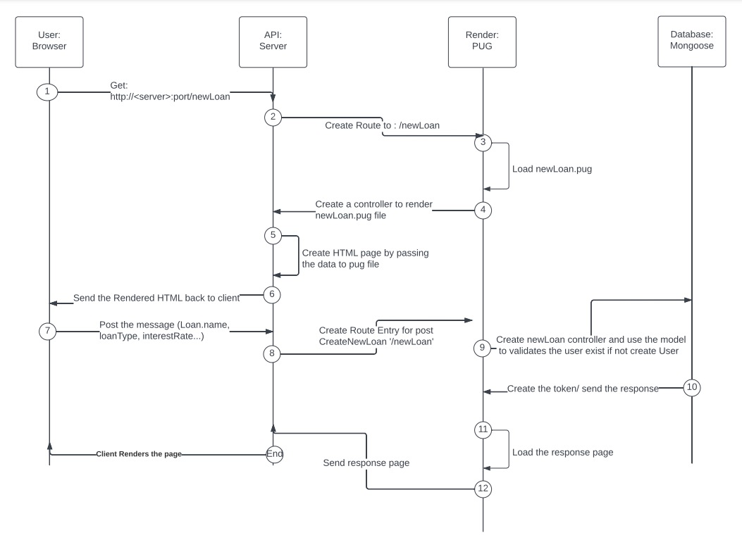

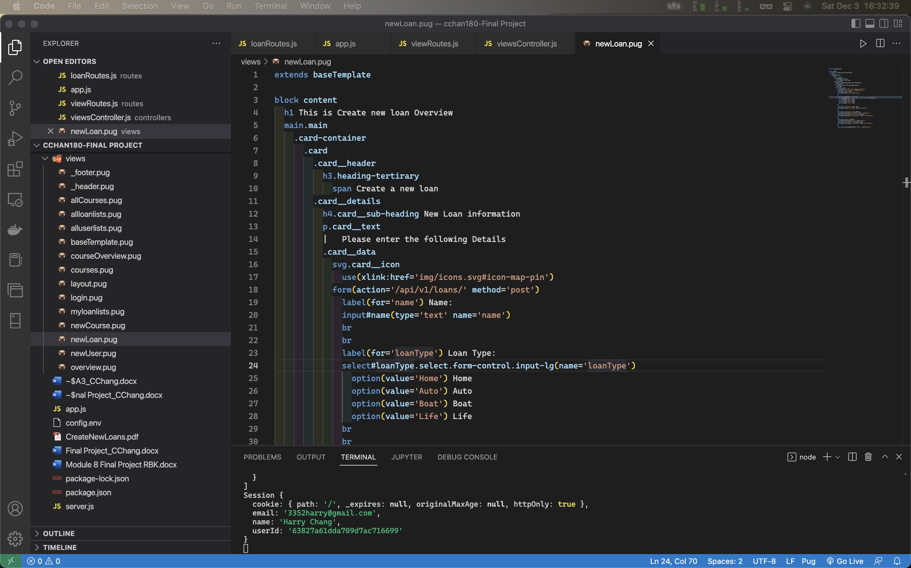

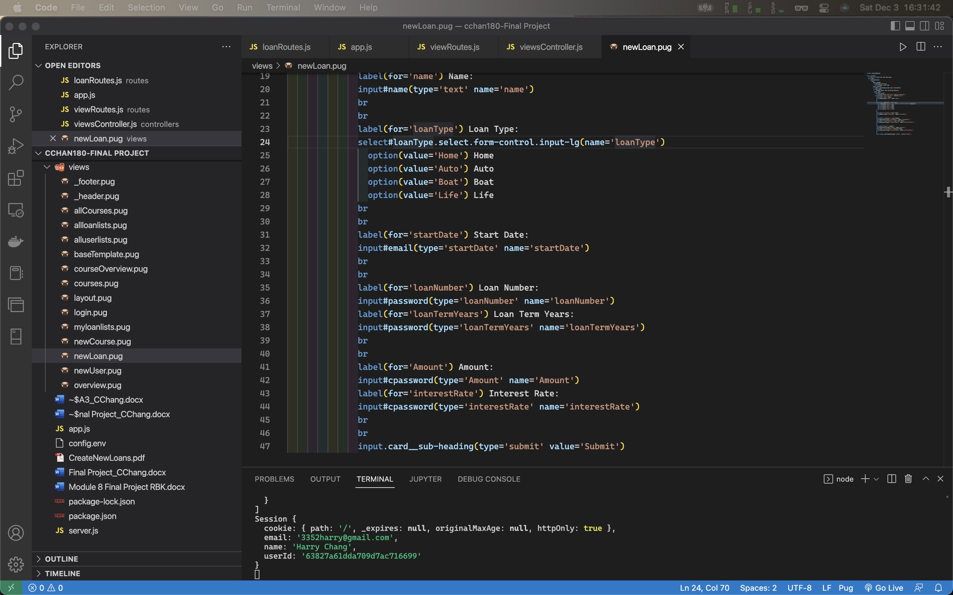

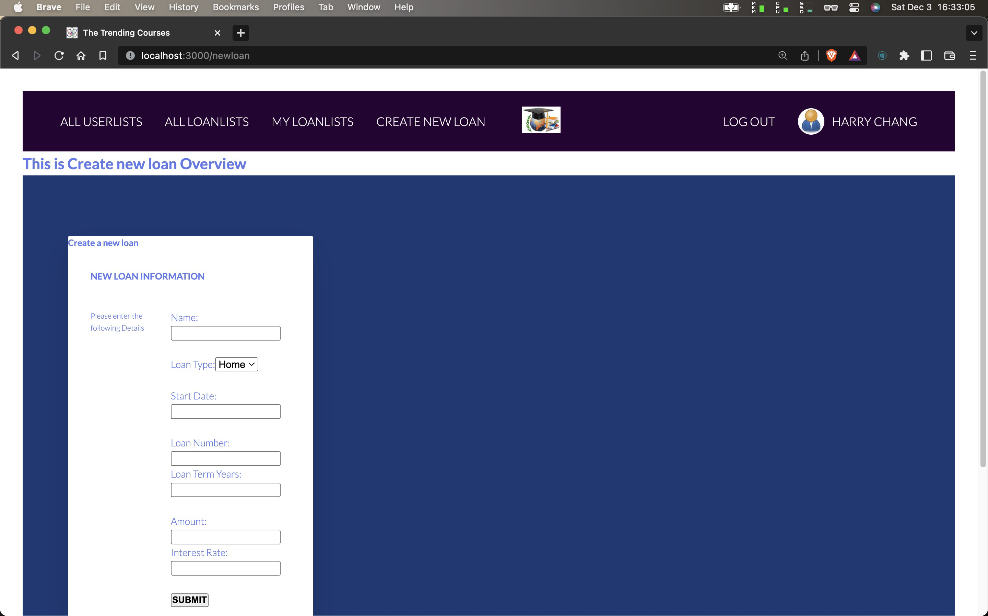

Code of newLoan.pug:

extends baseTemplate

block content

h1 This is Create new loan Overview

main.main

.card-container

.card

.card__header

h3.heading-tertirary

span Create a new loan

.card__details

h4.card__sub-heading New Loan information

p.card__text

| Please enter the following Details

.card__data

svg.card__icon

use(xlink:href='img/icons.svg#icon-map-pin')

form(action='/api/v1/loans/' method='post')

label(for='name') Name:

input#name(type='text' name='name')

br

br

label(for='loanType') Loan Type:

select#loanType.select.form-control.input-lg(name='loanType')

option(value='Home') Home

option(value='Auto') Auto

option(value='Boat') Boat

option(value='Life') Life

br

br

label(for='startDate') Start Date:

input#email(type='startDate' name='startDate')

br

br

label(for='loanNumber') Loan Number:

input#password(type='loanNumber' name='loanNumber')

label(for='loanTermYears') Loan Term Years:

input#password(type='loanTermYears' name='loanTermYears')

br

br

label(for='Amount') Amount:

input#cpassword(type='Amount' name='Amount')

label(for='interestRate') Interest Rate:

input#cpassword(type='interestRate' name='interestRate')

br

br

input.card__sub-heading(type='submit' value='Submit')

## List Loan details (**Create new flow diagram)

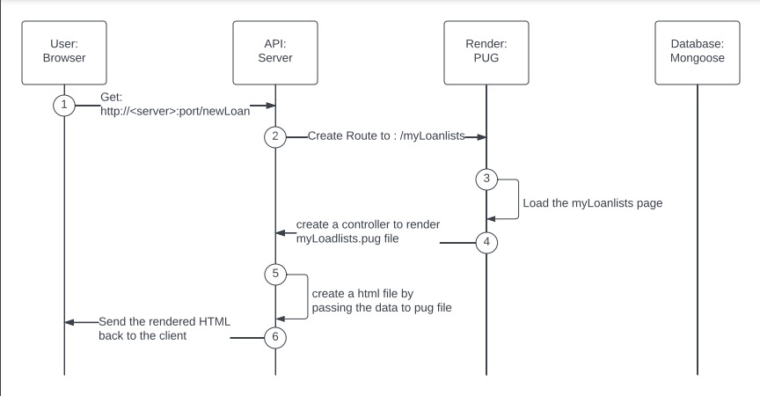

Screenshot of my loan lists

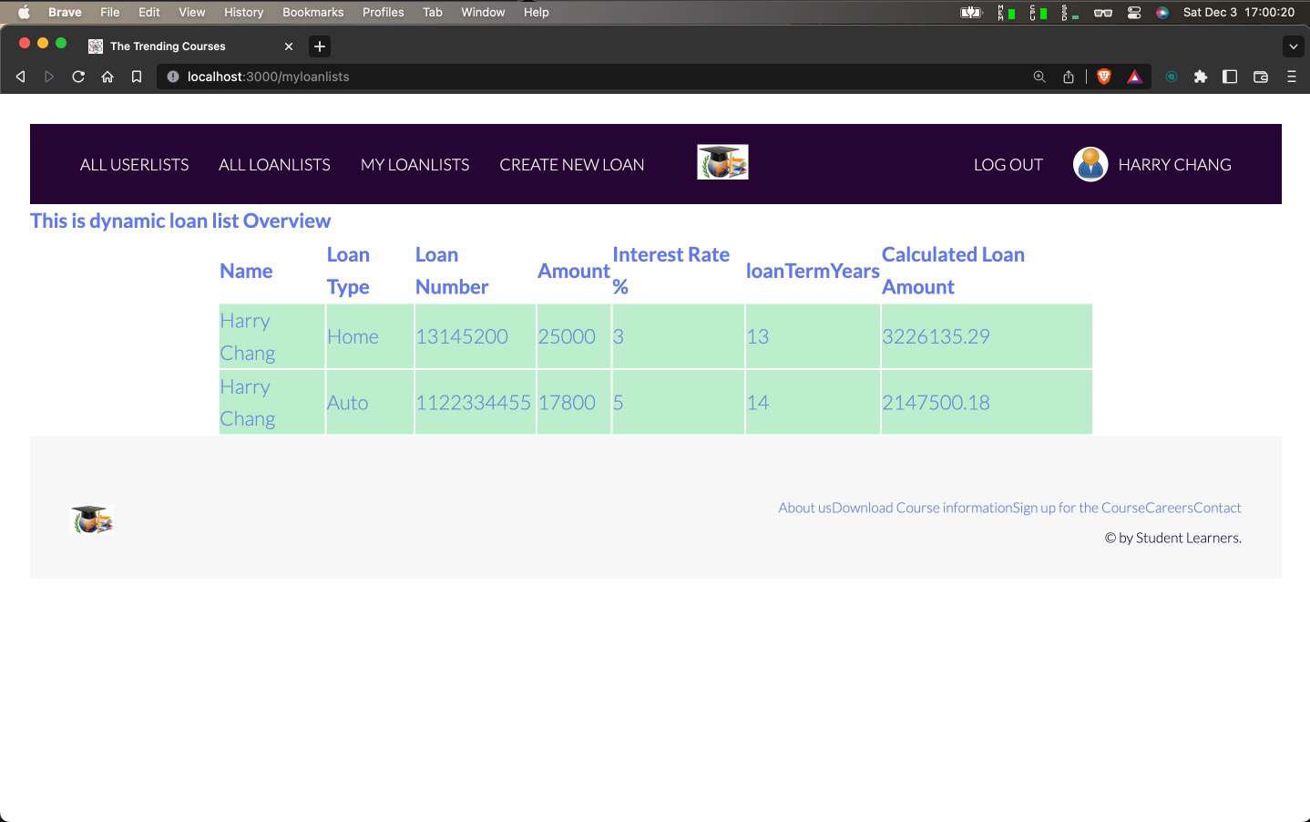

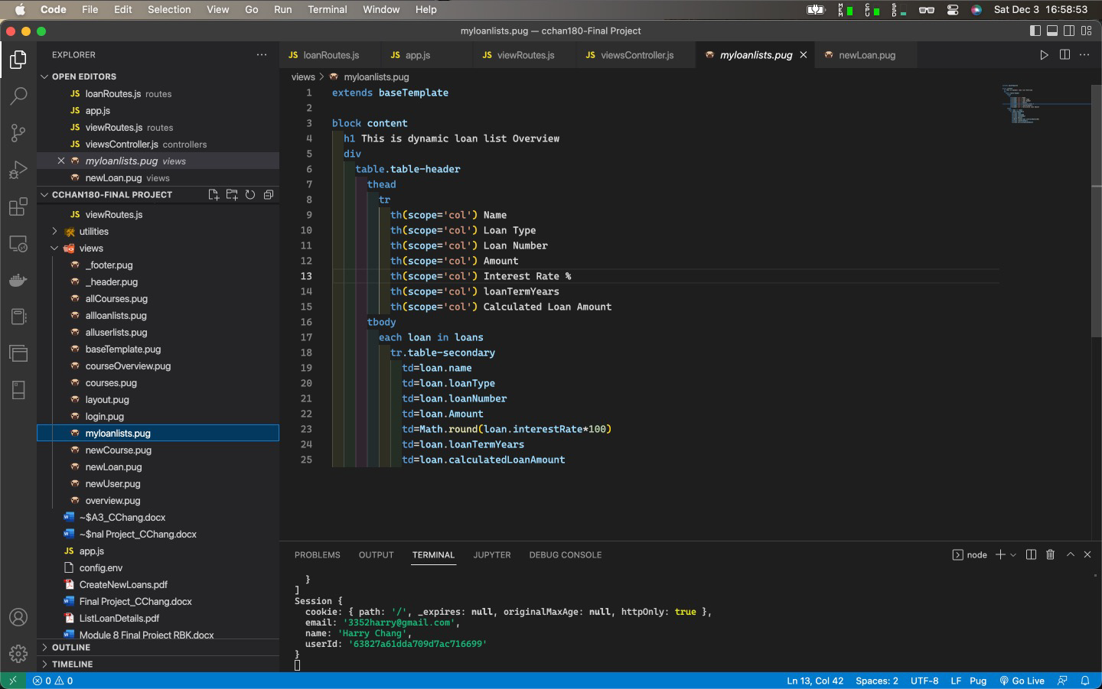

extends baseTemplate

block content

h1 This is dynamic loan list Overview

div

table.table-header

thead

tr

th(scope='col') Name

th(scope='col') Loan Type

th(scope='col') Loan Number

th(scope='col') Amount

th(scope='col') Interest Rate %

th(scope='col') Loan Term Years

th(scope='col') Calculated Loan Amount

tbody

each loan in loans

tr.table-secondary

td=loan.name

td=loan.loanType

td=loan.loanNumber

td=loan.Amount

td=Math.round(loan.interestRate*100)

td=loan.loanTermYears

td=loan.calculatedLoanAmount

Screenshot of All Loan lists

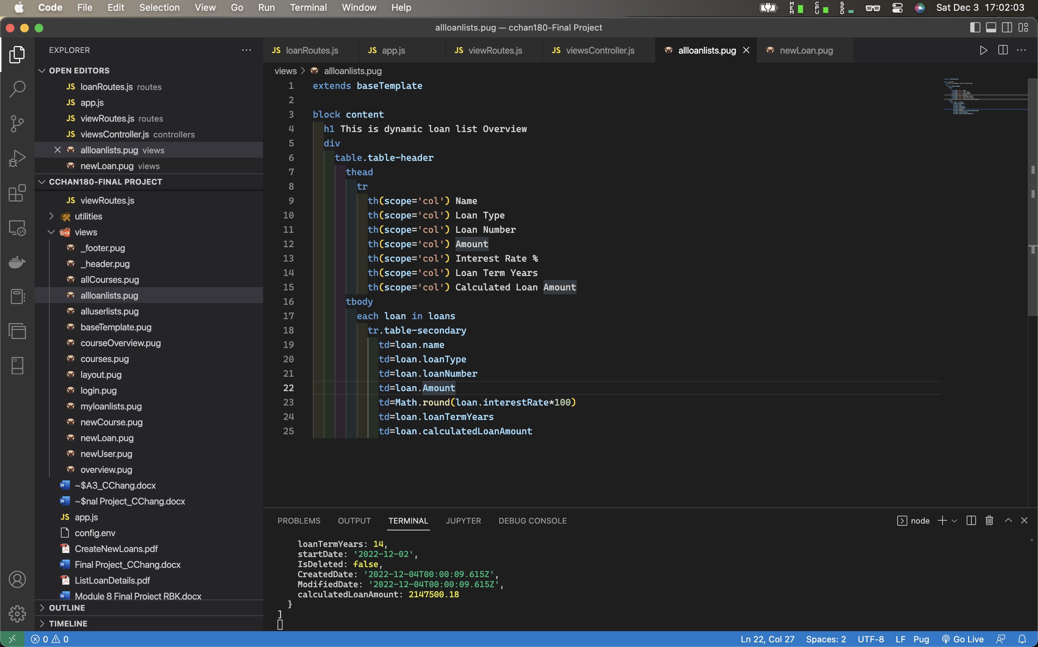

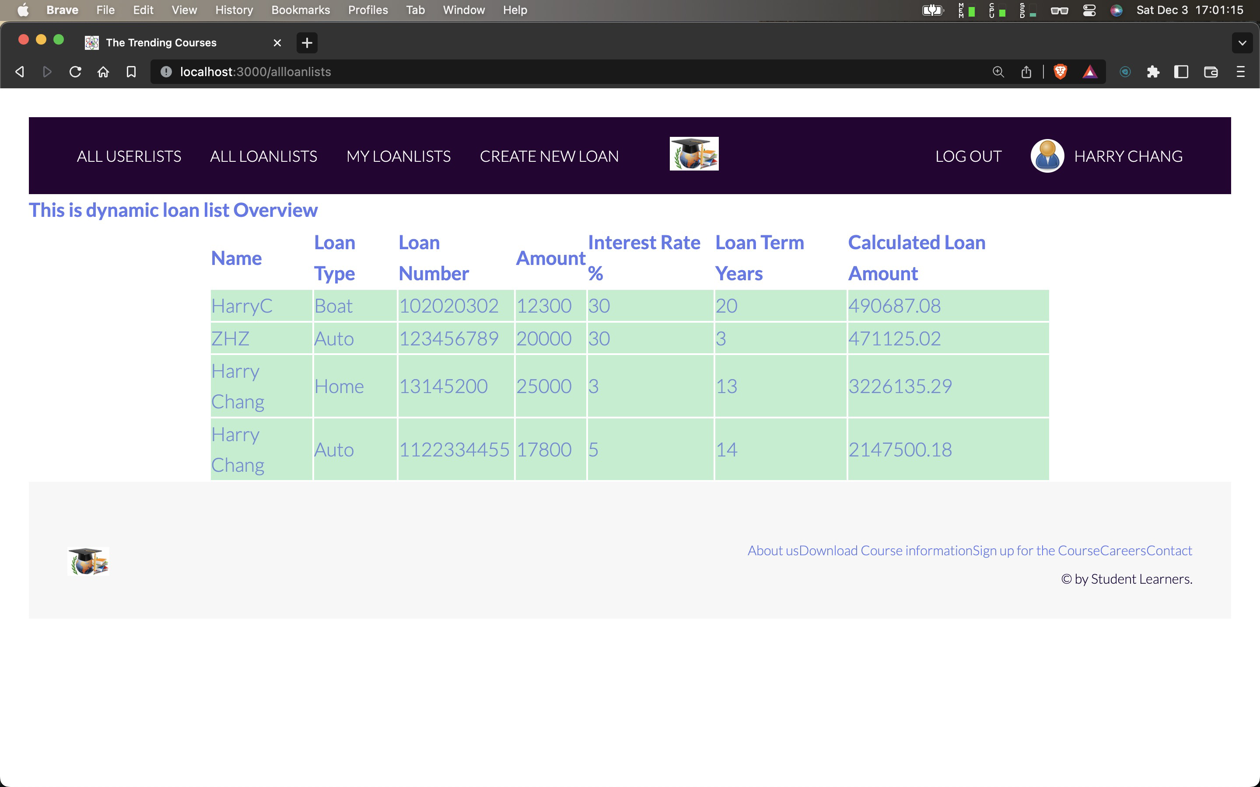

Code of allloanlists.pug

extends baseTemplate

block content

h1 This is dynamic loan list Overview

div

table.table-header

thead

tr

th(scope='col') Name

th(scope='col') Loan Type

th(scope='col') Loan Number

th(scope='col') Amount

th(scope='col') Interest Rate %

th(scope='col') Loan Term Years

th(scope='col') Calculated Loan Amount

tbody

each loan in loans

tr.table-secondary

td=loan.name

td=loan.loanType

td=loan.loanNumber

td=loan.Amount

td=Math.round(loan.interestRate*100)

td=loan.loanTermYears

td=loan.calculatedLoanAmount

# Middleware: API

## Create New User

userAuthRoutes.js

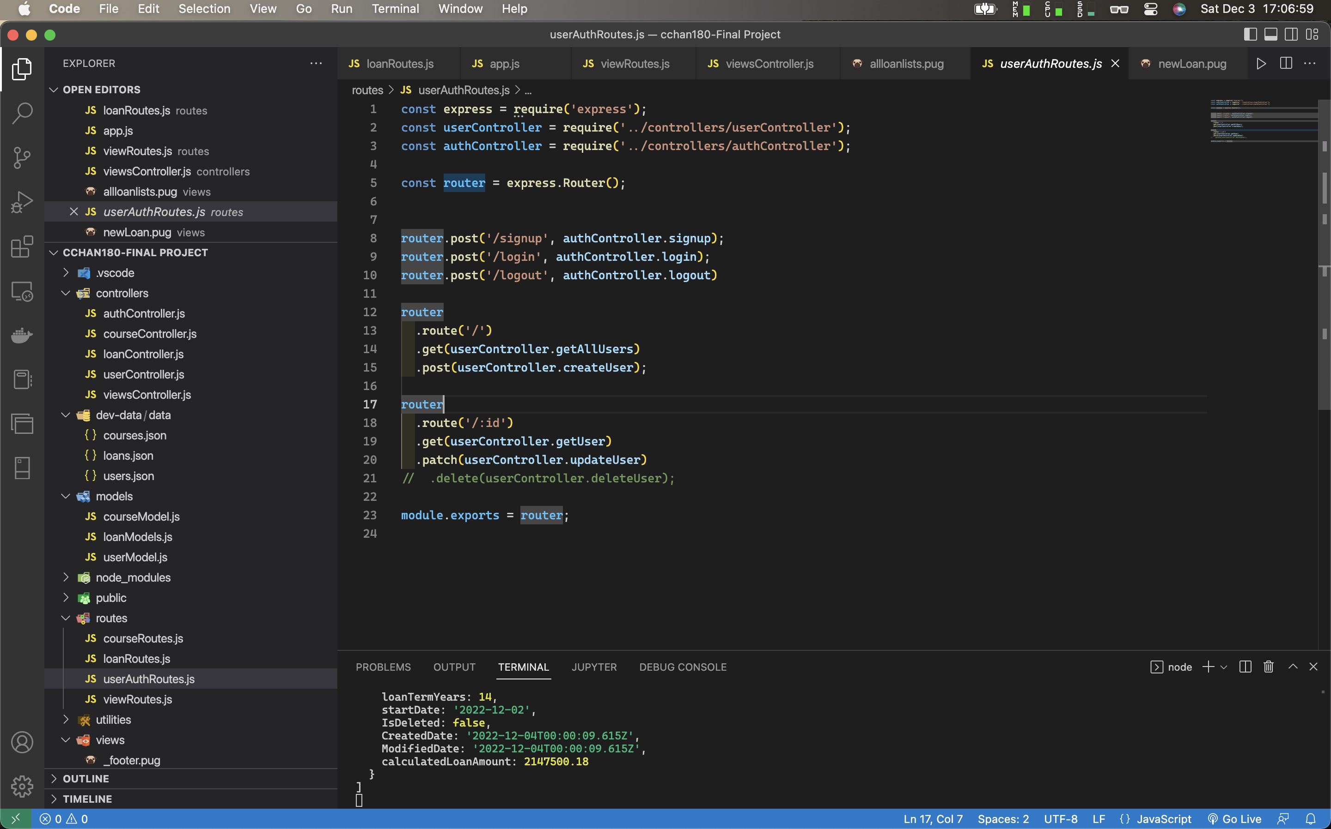

const express = require('express');

const userController = require('../controllers/userController');

const authController = require('../controllers/authController');

const router = express.Router();

router.post('/signup', authController.signup);

router.post('/login', authController.login);

router.post('/logout', authController.logout)

router

.route('/')

.get(userController.getAllUsers)

.post(userController.createUser);

router

.route('/:id')

.get(userController.getUser)

.patch(userController.updateUser)

// .delete(userController.deleteUser);

module.exports = router;

authController.js

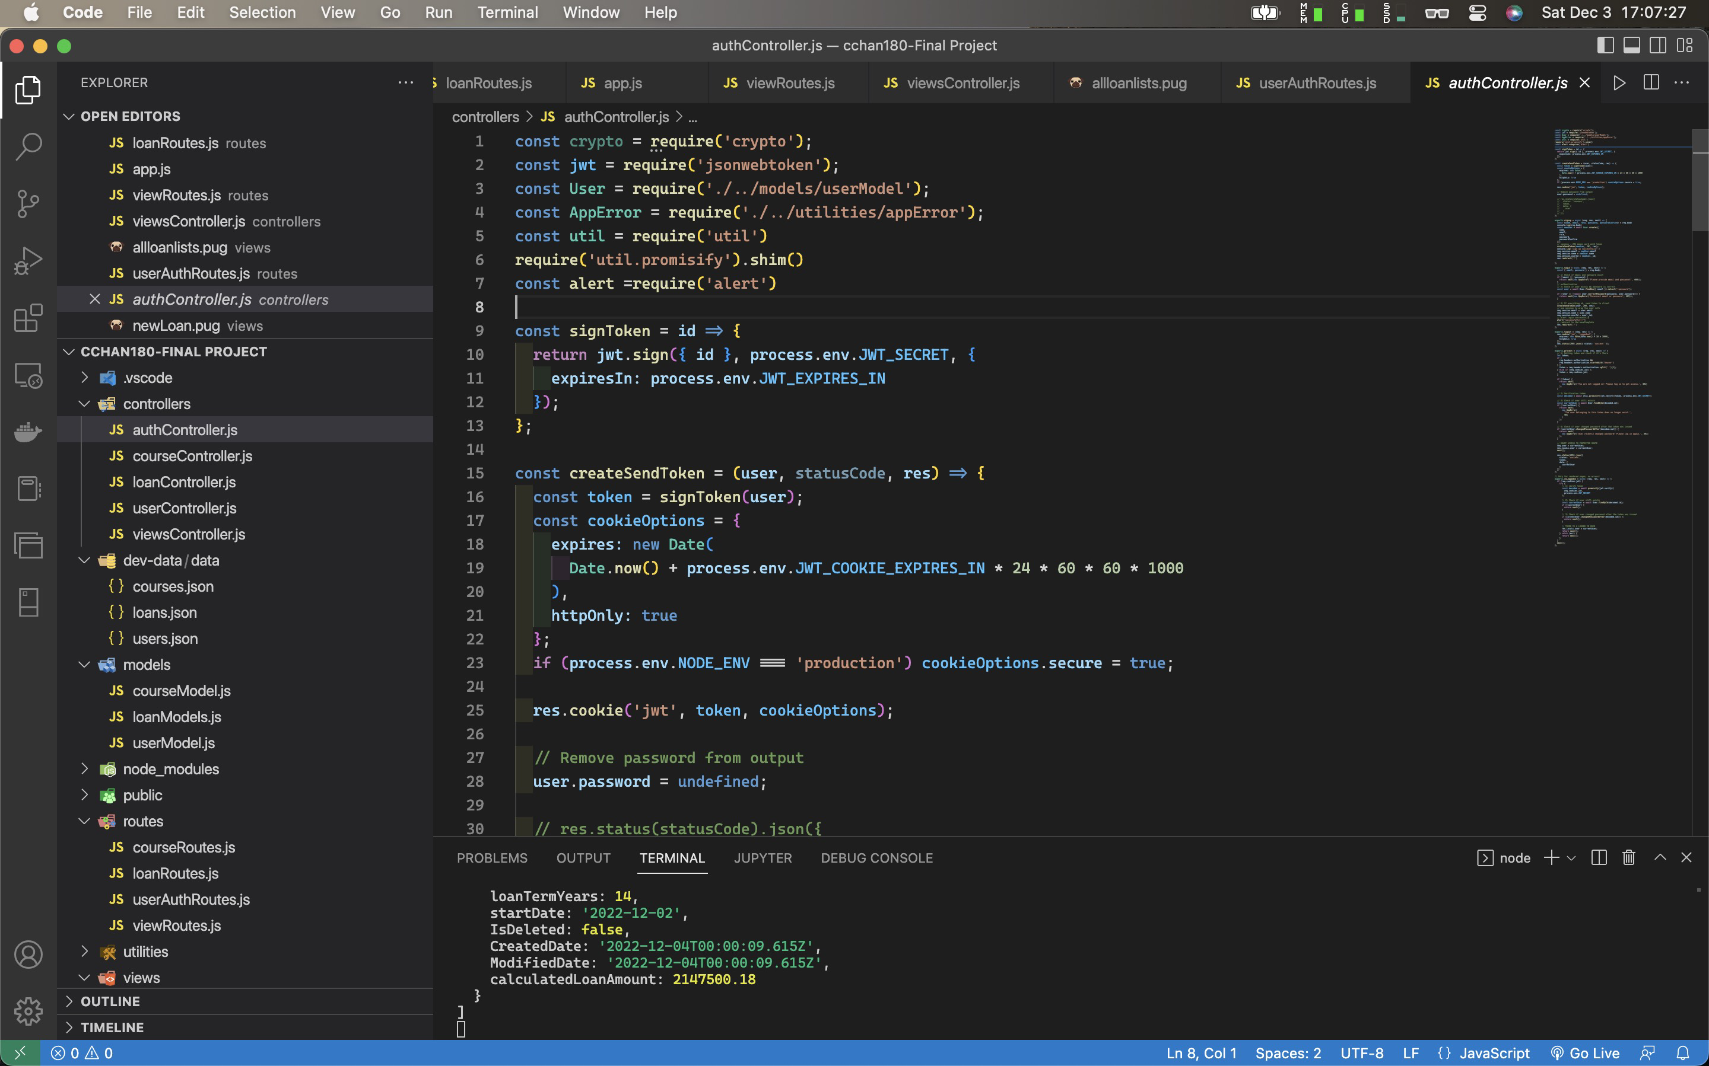

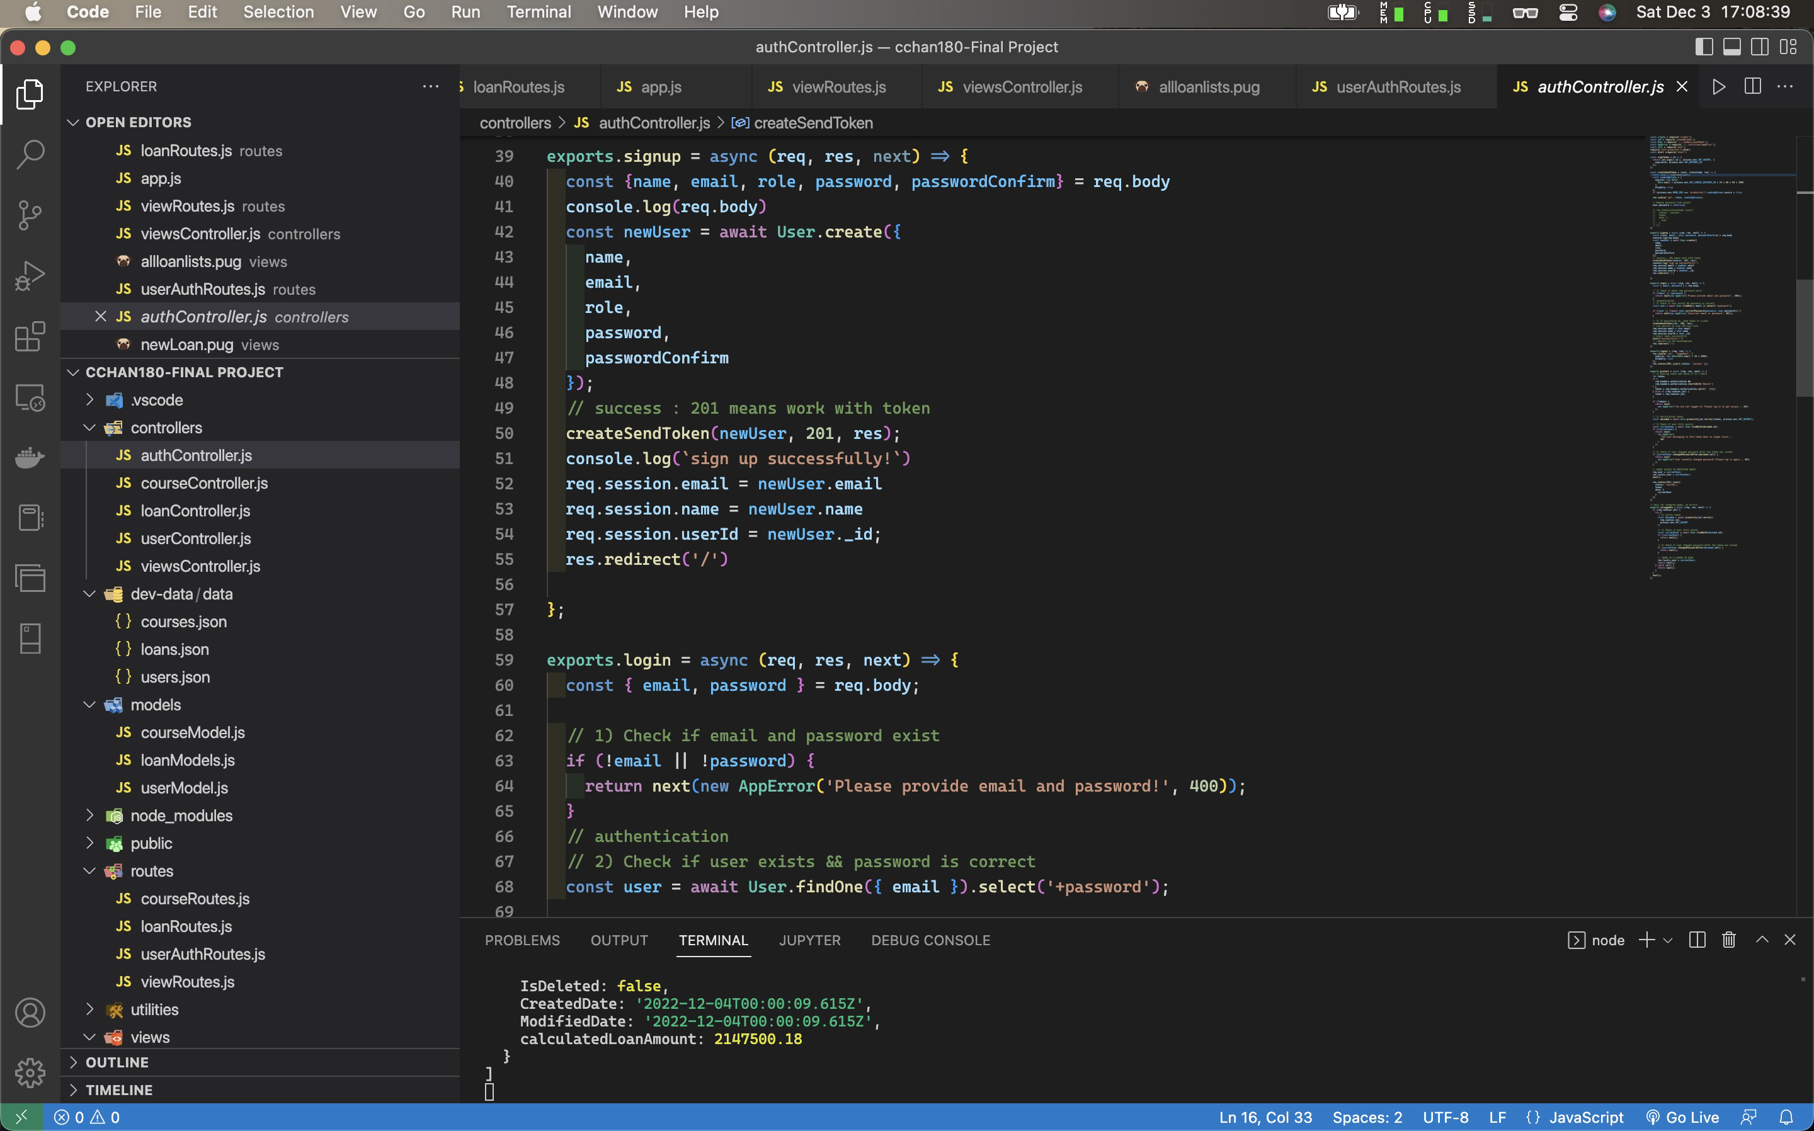

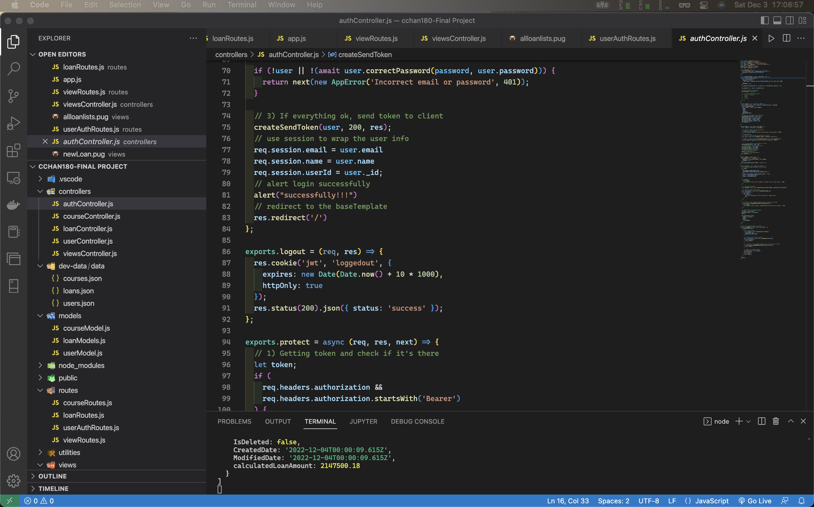

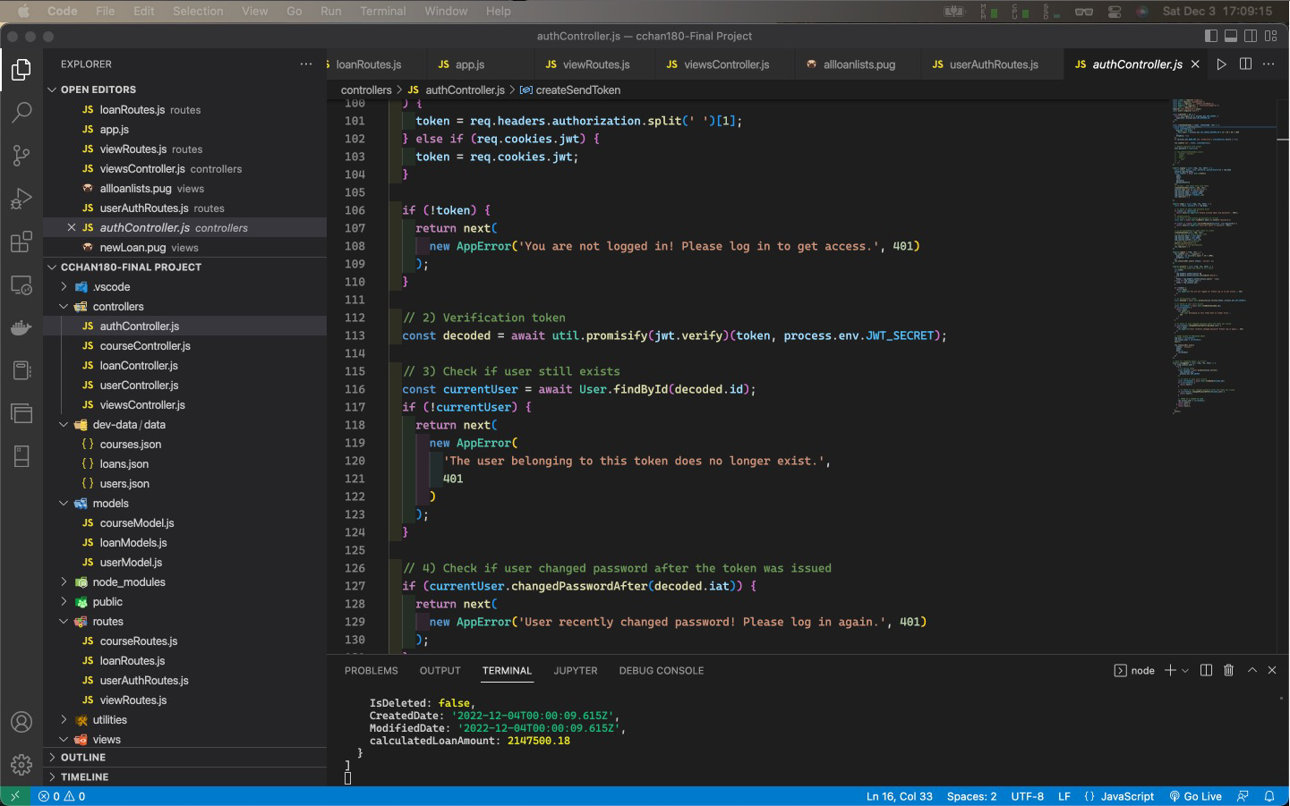

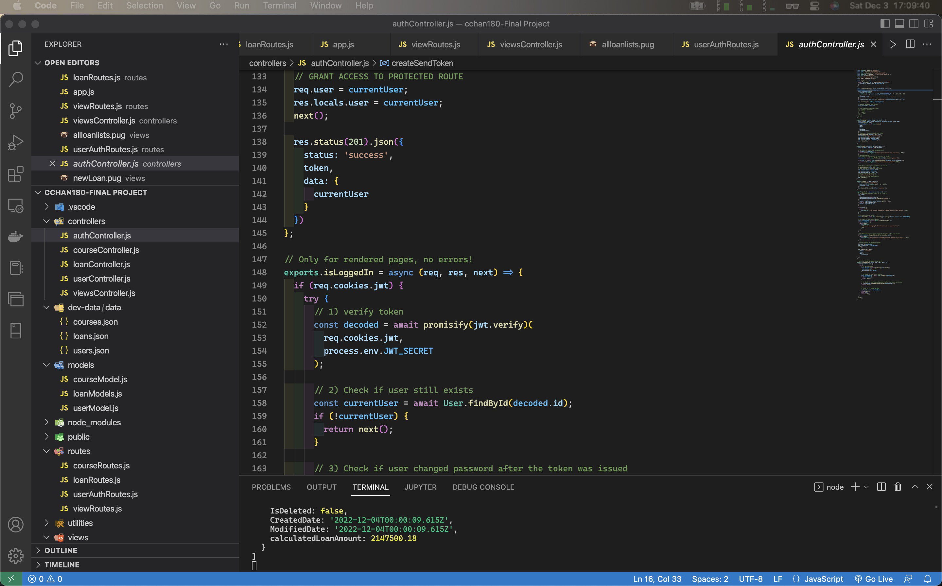

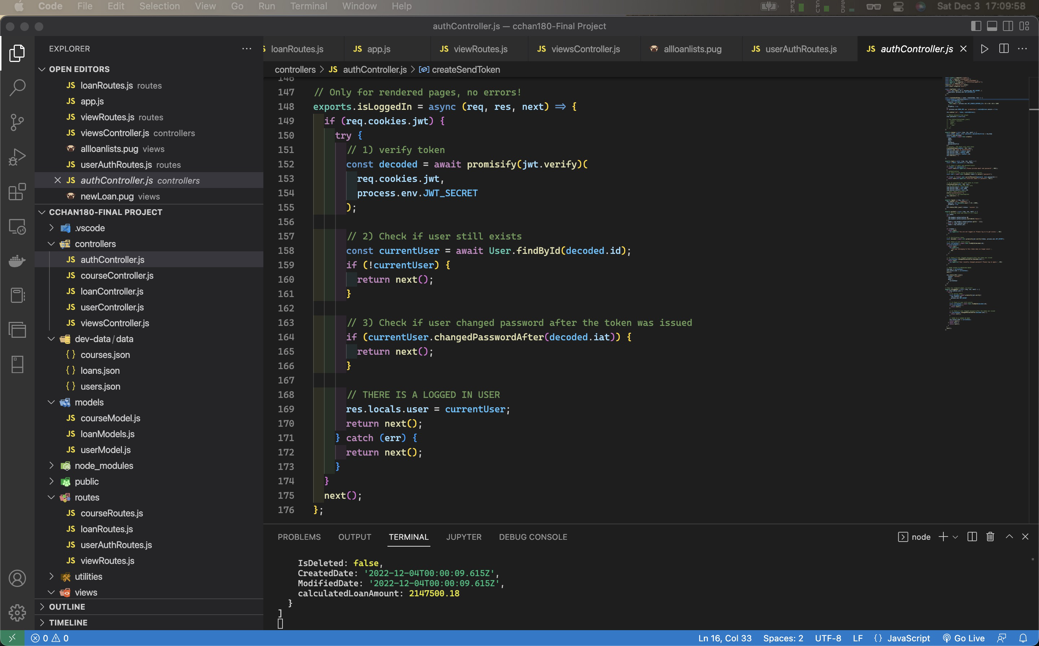

Code of authController.js

const crypto = require('crypto');

const jwt = require('jsonwebtoken');

const User = require('./../models/userModel');

const AppError = require('./../utilities/appError');

const util = require('util')

require('util.promisify').shim()

const alert =require('alert')

const signToken = id => {

return jwt.sign({ id }, process.env.JWT_SECRET, {

expiresIn: process.env.JWT_EXPIRES_IN

});

};

const createSendToken = (user, statusCode, res) => {

const token = signToken(user);

const cookieOptions = {

expires: new Date(

Date.now() + process.env.JWT_COOKIE_EXPIRES_IN * 24 * 60 * 60 * 1000

),

httpOnly: true

};

if (process.env.NODE_ENV === 'production') cookieOptions.secure = true;

res.cookie('jwt', token, cookieOptions);

// Remove password from output

user.password = undefined;

};

exports.signup = async (req, res, next) => {

const {name, email, role, password, passwordConfirm} = req.body

console.log(req.body)

const newUser = await User.create({

name,

email,

role,

password,

passwordConfirm

});

// success : 201 means work with token

createSendToken(newUser, 201, res);

console.log(`sign up successfully!`)

req.session.email = newUser.email

req.session.name = newUser.name

req.session.userId = newUser._id;

res.redirect('/')

};

exports.login = async (req, res, next) => {

const { email, password } = req.body;

// 1) Check if email and password exist

if (!email || !password) {

return next(new AppError('Please provide email and password!', 400));

}

// authentication

// 2) Check if user exists && password is correct

const user = await User.findOne({ email }).select('+password');

if (!user || !(await user.correctPassword(password, user.password))) {

return next(new AppError('Incorrect email or password', 401));

}

// 3) If everything ok, send token to client

createSendToken(user, 200, res);

// use session to wrap the user info

req.session.email = user.email

req.session.name = user.name

req.session.userId = user._id;

// alert login successfully

alert("successfully!!!")

// redirect to the baseTemplate

res.redirect('/')

};

exports.logout = (req, res) => {

res.cookie('jwt', 'loggedout', {

expires: new Date(Date.now() + 10 * 1000),

httpOnly: true

});

res.status(200).json({ status: 'success' });

};

exports.protect = async (req, res, next) => {

// 1) Getting token and check if it's there

let token;

if (

req.headers.authorization &&

req.headers.authorization.startsWith('Bearer')

) {

token = req.headers.authorization.split(' ')[1];

} else if (req.cookies.jwt) {

token = req.cookies.jwt;

}

if (!token) {

return next(

new AppError('You are not logged in! Please log in to get access.', 401)

);

}

// 2) Verification token

const decoded = await util.promisify(jwt.verify)(token, process.env.JWT_SECRET);

// 3) Check if user still exists

const currentUser = await User.findById(decoded.id);

if (!currentUser) {

return next(

new AppError(

'The user belonging to this token does no longer exist.',

401

)

);

}

// 4) Check if user changed password after the token was issued

if (currentUser.changedPasswordAfter(decoded.iat)) {

return next(

new AppError('User recently changed password! Please log in again.', 401)

);

}

// GRANT ACCESS TO PROTECTED ROUTE

req.user = currentUser;

res.locals.user = currentUser;

next();

res.status(201).json({

status: 'success',

token,

data: {

currentUser

}

})

};

// Only for rendered pages, no errors!

exports.isLoggedIn = async (req, res, next) => {

if (req.cookies.jwt) {

try {

// 1) verify token

const decoded = await promisify(jwt.verify)(

req.cookies.jwt,

process.env.JWT_SECRET

);

// 2) Check if user still exists

const currentUser = await User.findById(decoded.id);

if (!currentUser) {

return next();

}

// 3) Check if user changed password after the token was issued

if (currentUser.changedPasswordAfter(decoded.iat)) {

return next();

}

// THERE IS A LOGGED IN USER

res.locals.user = currentUser;

return next();

} catch (err) {

return next();

}

}

next();

};

## LogIn Current User (Authentication)

Login function is in both userAuthRoutes.js and authController.js

Login function in authController.js

exports.login = async (req, res, next) => {

const { email, password } = req.body;

// 1) Check if email and password exist

if (!email || !password) {

return next(new AppError('Please provide email and password!', 400));

}

// authentication

// 2) Check if user exists && password is correct

const user = await User.findOne({ email }).select('+password');

if (!user || !(await user.correctPassword(password, user.password))) {

return next(new AppError('Incorrect email or password', 401));

}

// 3) If everything ok, send token to client

createSendToken(user, 200, res);

// use session to wrap the user info

req.session.email = user.email

req.session.name = user.name

req.session.userId = user._id;

// alert login successfully

alert("successfully!!!")

// redirect to the baseTemplate

res.redirect('/')

};

## Create New Loans (Protect Resources)

loanRoutes.js

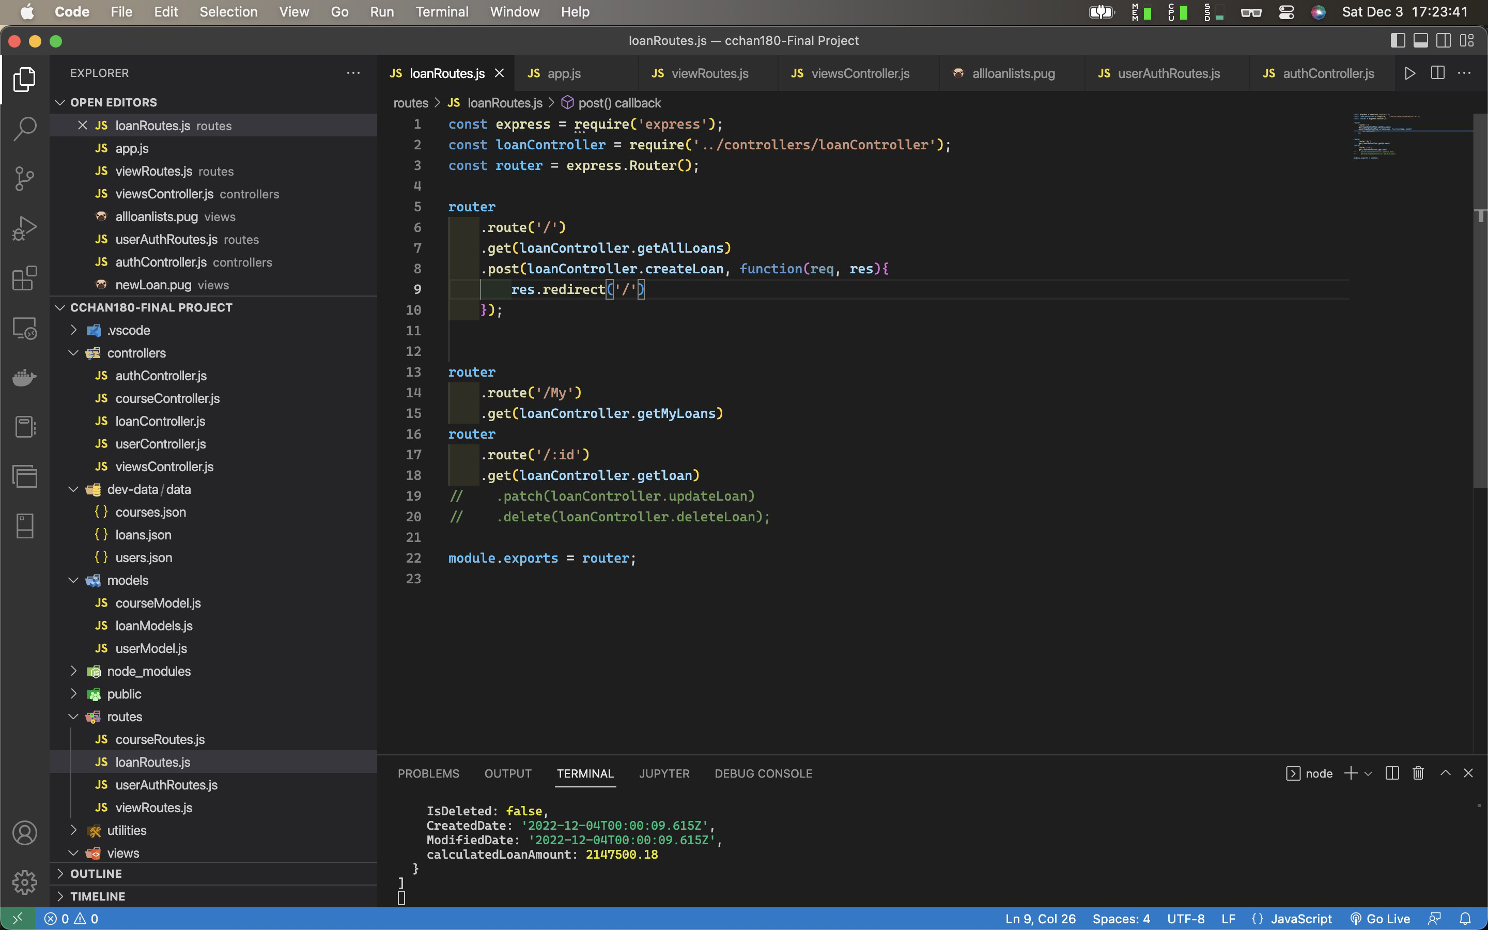

const express = require('express');

const loanController = require('../controllers/loanController');

const router = express.Router();

router

.route('/')

.get(loanController.getAllLoans)

.post(loanController.createLoan, function(req, res){

res.redirect('/')

});

router

.route('/My')

.get(loanController.getMyLoans)

router

.route('/:id')

.get(loanController.getloan)

// .patch(loanController.updateLoan)

// .delete(loanController.deleteLoan);

module.exports = router;

loanController.js

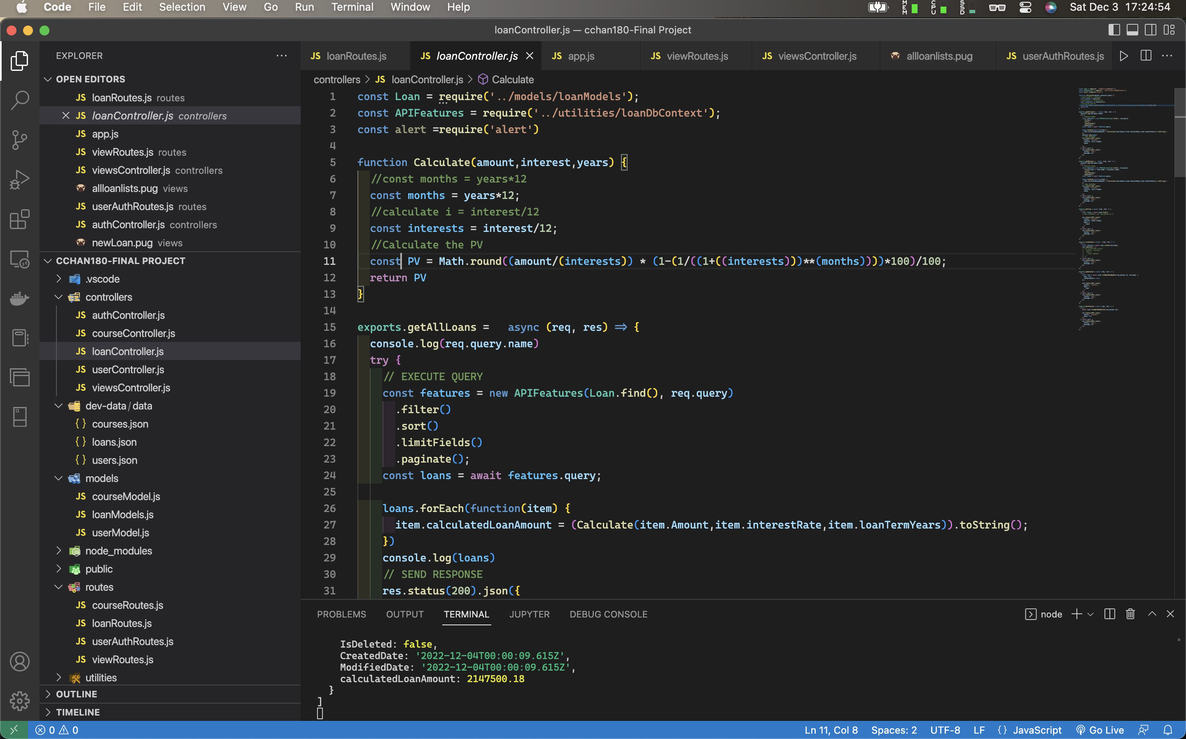

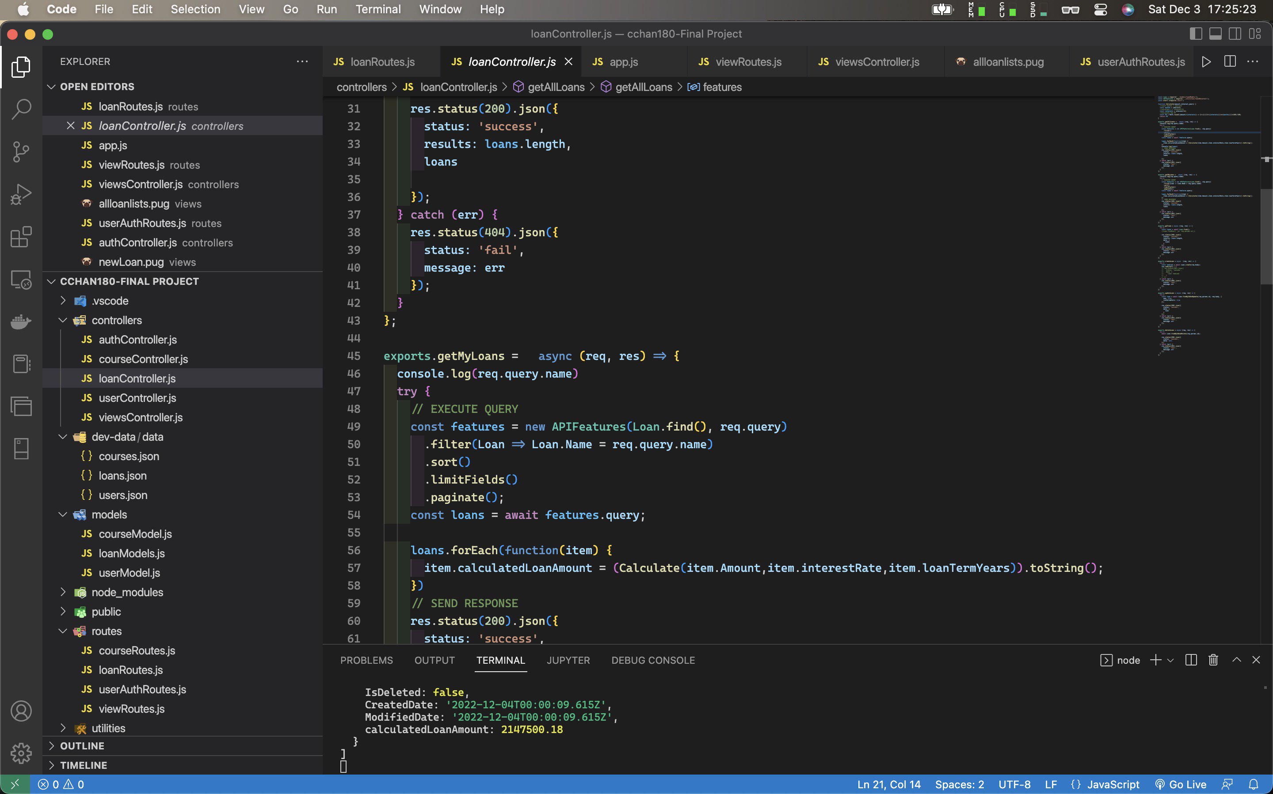

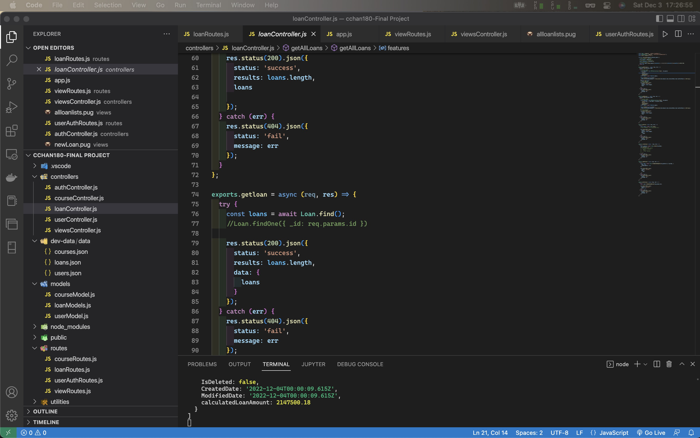

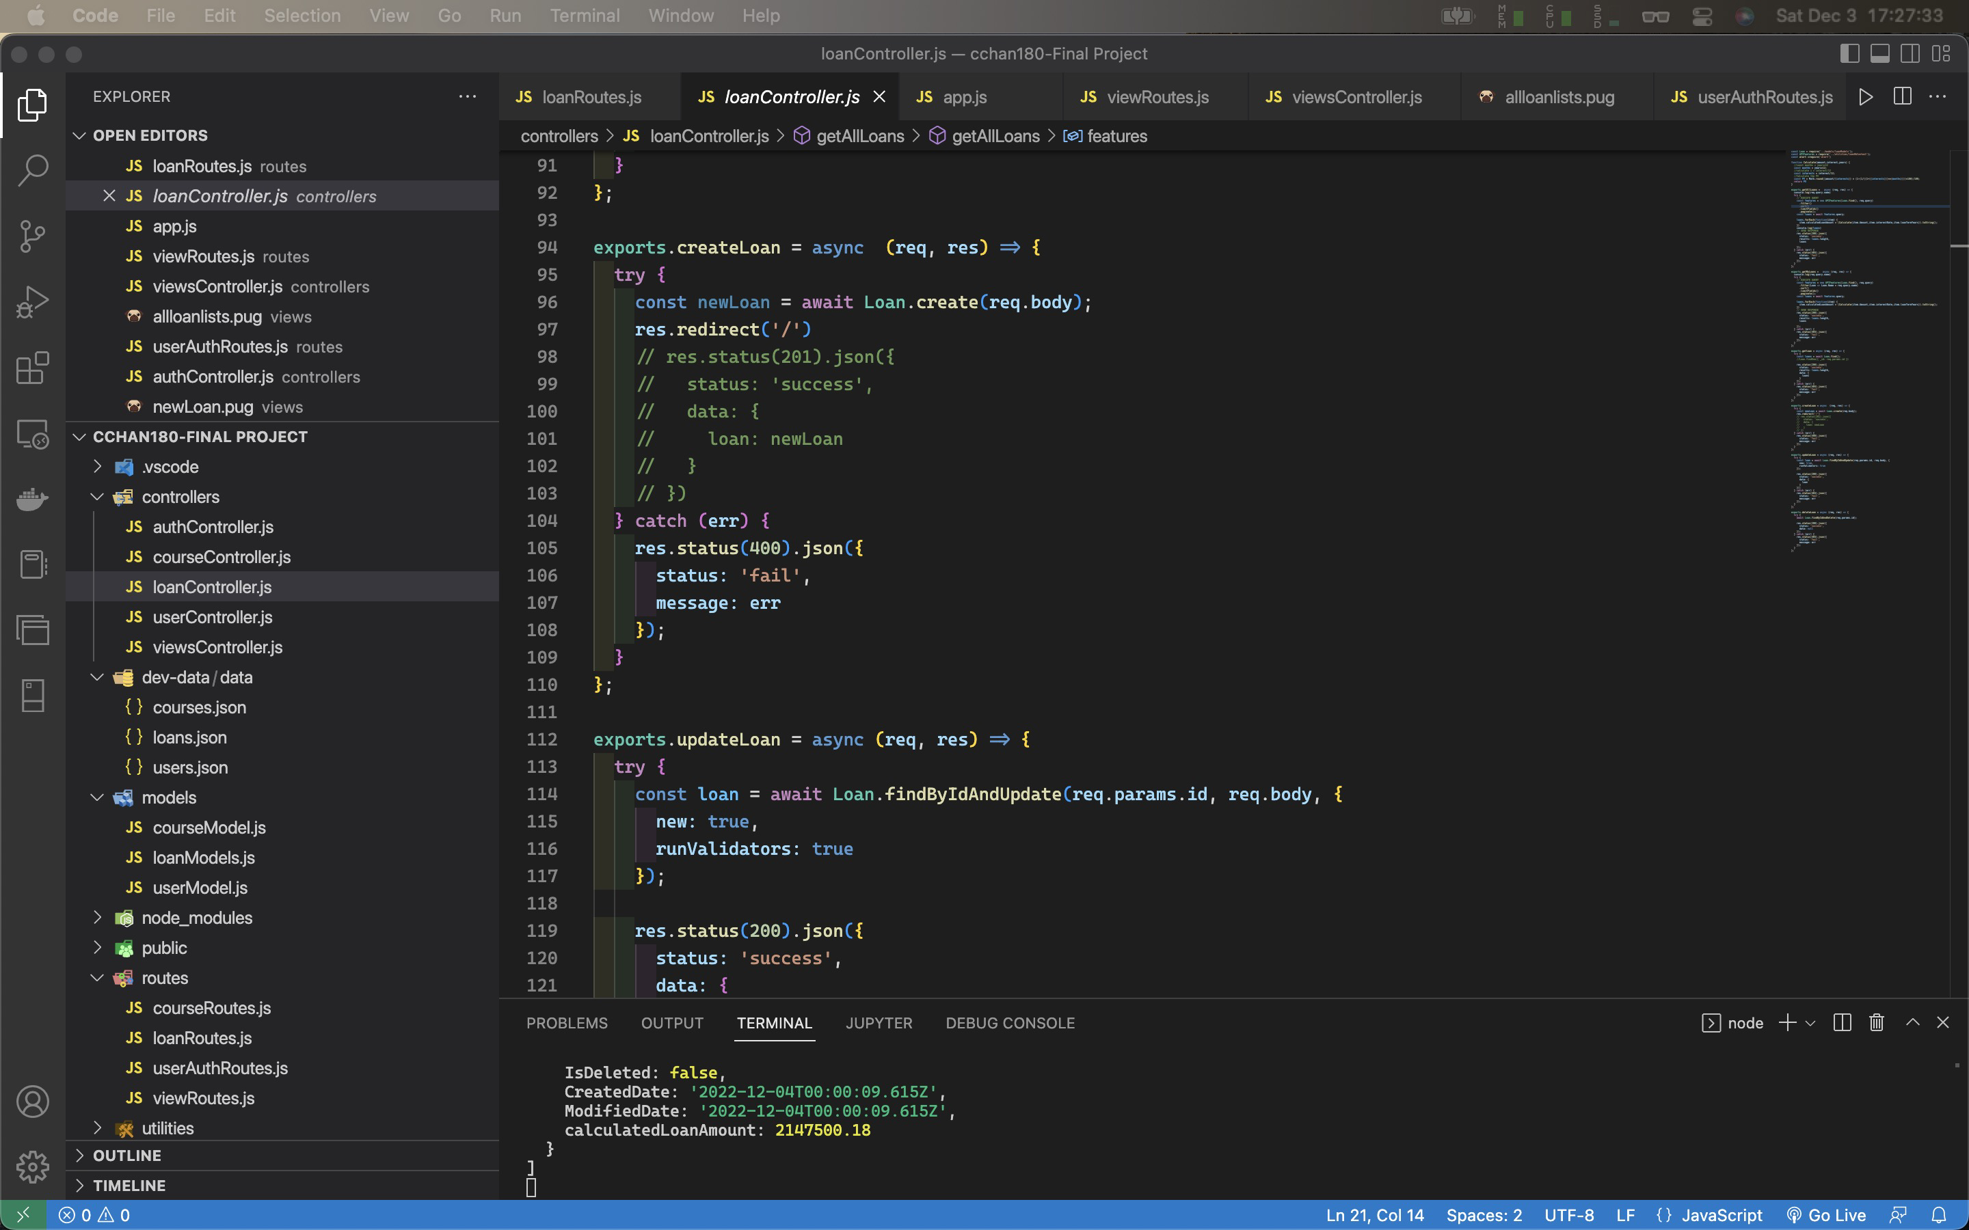

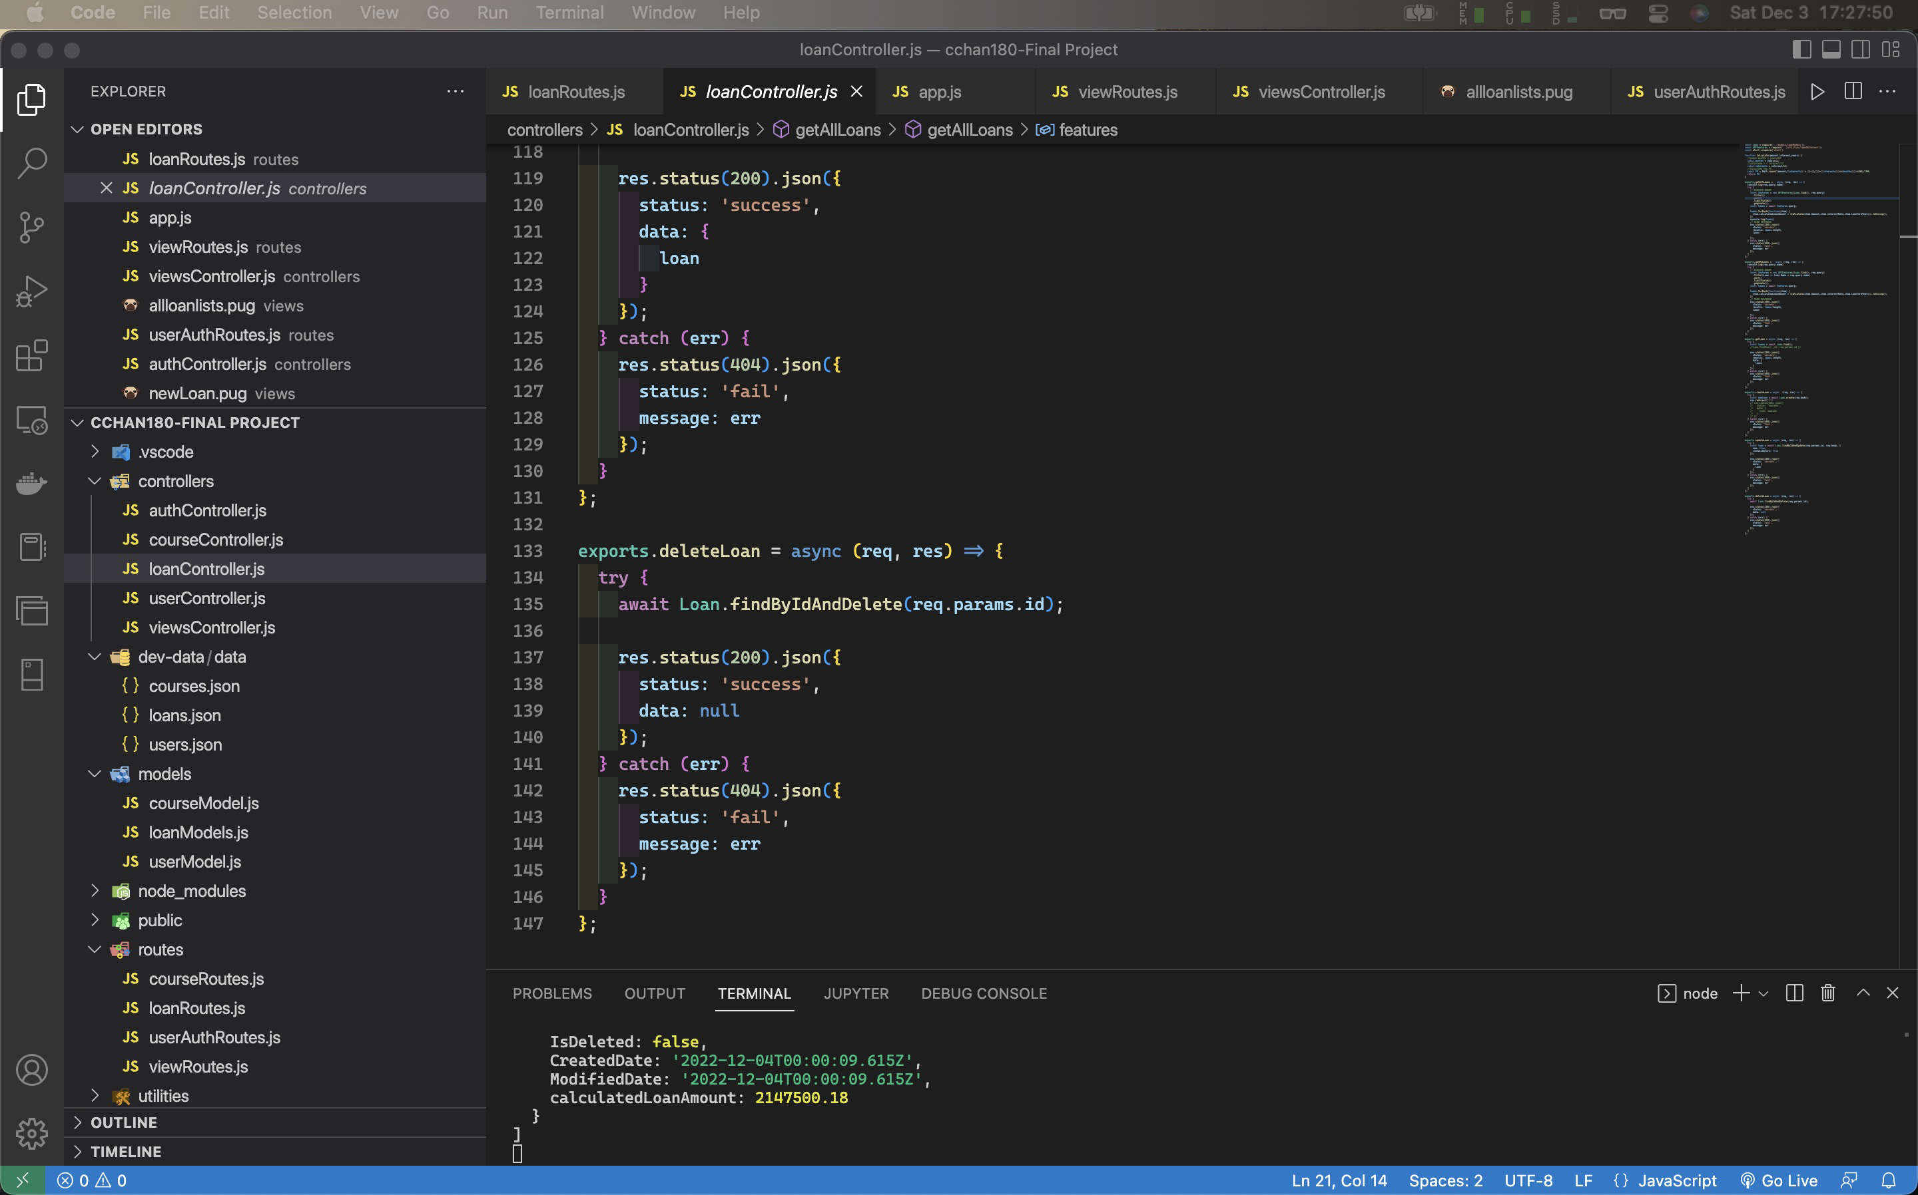

Code of loanController.js:

const Loan = require('../models/loanModels');

const APIFeatures = require('../utilities/loanDbContext');

const alert =require('alert')

function Calculate(amount,interest,years) {

//const months = years*12

const months = years*12;

//calculate i = interest/12

const interests = interest/12;

//Calculate the PV

const PV = Math.round((amount/(interests)) * (1-(1/((1+((interests)))**(months))))*100)/100;

return PV

}

exports.getAllLoans = async (req, res) => {

console.log(req.query.name)

try {

// EXECUTE QUERY

const features = new APIFeatures(Loan.find(), req.query)

.filter()

.sort()

.limitFields()

.paginate();

const loans = await features.query;

loans.forEach(function(item) {

item.calculatedLoanAmount = (Calculate(item.Amount,item.interestRate,item.loanTermYears)).toString();

})

console.log(loans)

// SEND RESPONSE

res.status(200).json({

status: 'success',

results: loans.length,

loans

});

} catch (err) {

res.status(404).json({

status: 'fail',

message: err

});

}

};

exports.getMyLoans = async (req, res) => {

console.log(req.query.name)

try {

// EXECUTE QUERY

const features = new APIFeatures(Loan.find(), req.query)

.filter(Loan => Loan.Name = req.query.name)

.sort()

.limitFields()

.paginate();

const loans = await features.query;

loans.forEach(function(item) {

item.calculatedLoanAmount = (Calculate(item.Amount,item.interestRate,item.loanTermYears)).toString();

})

// SEND RESPONSE

res.status(200).json({

status: 'success',

results: loans.length,

loans

});

} catch (err) {

res.status(404).json({

status: 'fail',

message: err

});

}

};

exports.getloan = async (req, res) => {

try {

const loans = await Loan.find();

//Loan.findOne({ _id: req.params.id })

res.status(200).json({

status: 'success',

results: loans.length,

data: {

loans

}

});

} catch (err) {

res.status(404).json({

status: 'fail',

message: err

});

}

};

exports.createLoan = async (req, res) => {

try {

const newLoan = await Loan.create(req.body);

res.redirect('/')

// res.status(201).json({

// status: 'success',

// data: {

// loan: newLoan

// }

// })

} catch (err) {

res.status(400).json({

status: 'fail',

message: err

});

}

};

exports.updateLoan = async (req, res) => {

try {

const loan = await Loan.findByIdAndUpdate(req.params.id, req.body, {

new: true,

runValidators: true

});

res.status(200).json({

status: 'success',

data: {

loan

}

});

} catch (err) {

res.status(404).json({

status: 'fail',

message: err

});

}

};

exports.deleteLoan = async (req, res) => {

try {

await Loan.findByIdAndDelete(req.params.id);

res.status(200).json({

status: 'success',

data: null

});

} catch (err) {

res.status(404).json({

status: 'fail',

message: err

});

}

};

## List Loan Details (Protect Resources)

getMyloans and getAllloans both list Loan Details

exports.getMyLoans = async (req, res) => {

console.log(req.query.name)

try {

// EXECUTE QUERY

const features = new APIFeatures(Loan.find(), req.query)

.filter(Loan => Loan.Name = req.query.name)

.sort()

.limitFields()

.paginate();

const loans = await features.query;

loans.forEach(function(item) {

item.calculatedLoanAmount = (Calculate(item.Amount,item.interestRate,item.loanTermYears)).toString();

})

// SEND RESPONSE

res.status(200).json({

status: 'success',

results: loans.length,

loans

});

} catch (err) {

res.status(404).json({

status: 'fail',

message: err

});

}

};

exports.getAllLoans = async (req, res) => {

console.log(req.query.name)

try {

// EXECUTE QUERY

const features = new APIFeatures(Loan.find(), req.query)

.filter()

.sort()

.limitFields()

.paginate();

const loans = await features.query;

loans.forEach(function(item) {

item.calculatedLoanAmount = (Calculate(item.Amount,item.interestRate,item.loanTermYears)).toString();

})

console.log(loans)

// SEND RESPONSE

res.status(200).json({

status: 'success',

results: loans.length,

loans

});

} catch (err) {

res.status(404).json({

status: 'fail',

message: err

});

}

};

# Back End:

## User Collection

userModel.js

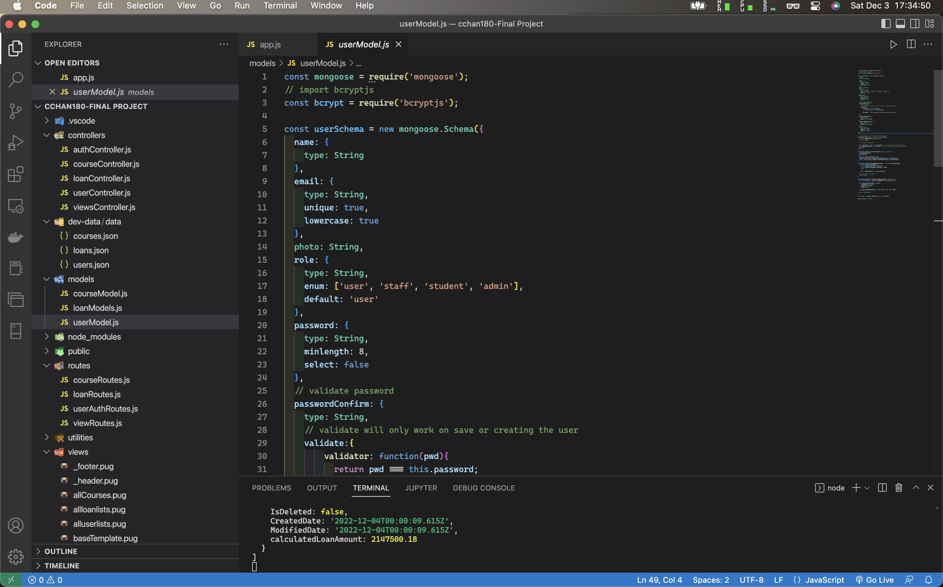

Code

const mongoose = require('mongoose');

// import bcryptjs

const bcrypt = require('bcryptjs');

const userSchema = new mongoose.Schema({

name: {

type: String

},

email: {

type: String,

unique: true,

lowercase: true

},

photo: String,

role: {

type: String,

enum: ['user', 'staff', 'student', 'admin'],

default: 'user'

},

password: {

type: String,

minlength: 8,

select: false

},

// validate password

passwordConfirm: {

type: String,

// validate will only work on save or creating the user

validate:{

validator: function(pwd){

return pwd === this.password;

},

message: " the password confirmation did not match"

}

},

passwordChangedAt: {

type: Date,

default: Date.now,

},

passwordResetExpires: {

type: Date,

default: Date.now

},

active: {

type: Boolean,

default: 'true',

select: 'false'

}

});

// add encryption to the password middleware

userSchema.pre('save', async function(next){

if(!this.isModified('password')){

return next;

}

// if new and modified

this.password = await this.password; // how intensive the CPU will be

this.passwordConfirm = undefined; // we do not want to store in database

next();

});

userSchema.methods.correctPassword = async function (

candidatePassword,

userPassword

) {

console.log(candidatePassword)

console.log(bcrypt.compare(candidatePassword, userPassword))

return await bcrypt.compare(candidatePassword, userPassword)

}

userSchema.methods.changedPasswordAfter = function(JWTTimeStamp){

if (this.passwordChangedAt) {

const changedTimeStamp = parseInt(

this.passwordChangedAt.getTime() /1000,

10

)

return JWTTimeStamp < changedTimeStamp

}

// false means no change

return false

}

userSchema.methods.createPasswordResetToken = function() {

const resetToken = crypto.randomBytes(32).toString('hex')

this.passwordResetToken = crypto

.createHash('sha256')

.update(resetToken)

.digest('hex')

this.passwordResetExpires = Date.now() + 10 * 60 * 1000;

return resetToken

}

const User = mongoose.model('User', userSchema);

module.exports = User;

User collection in MongoDB:

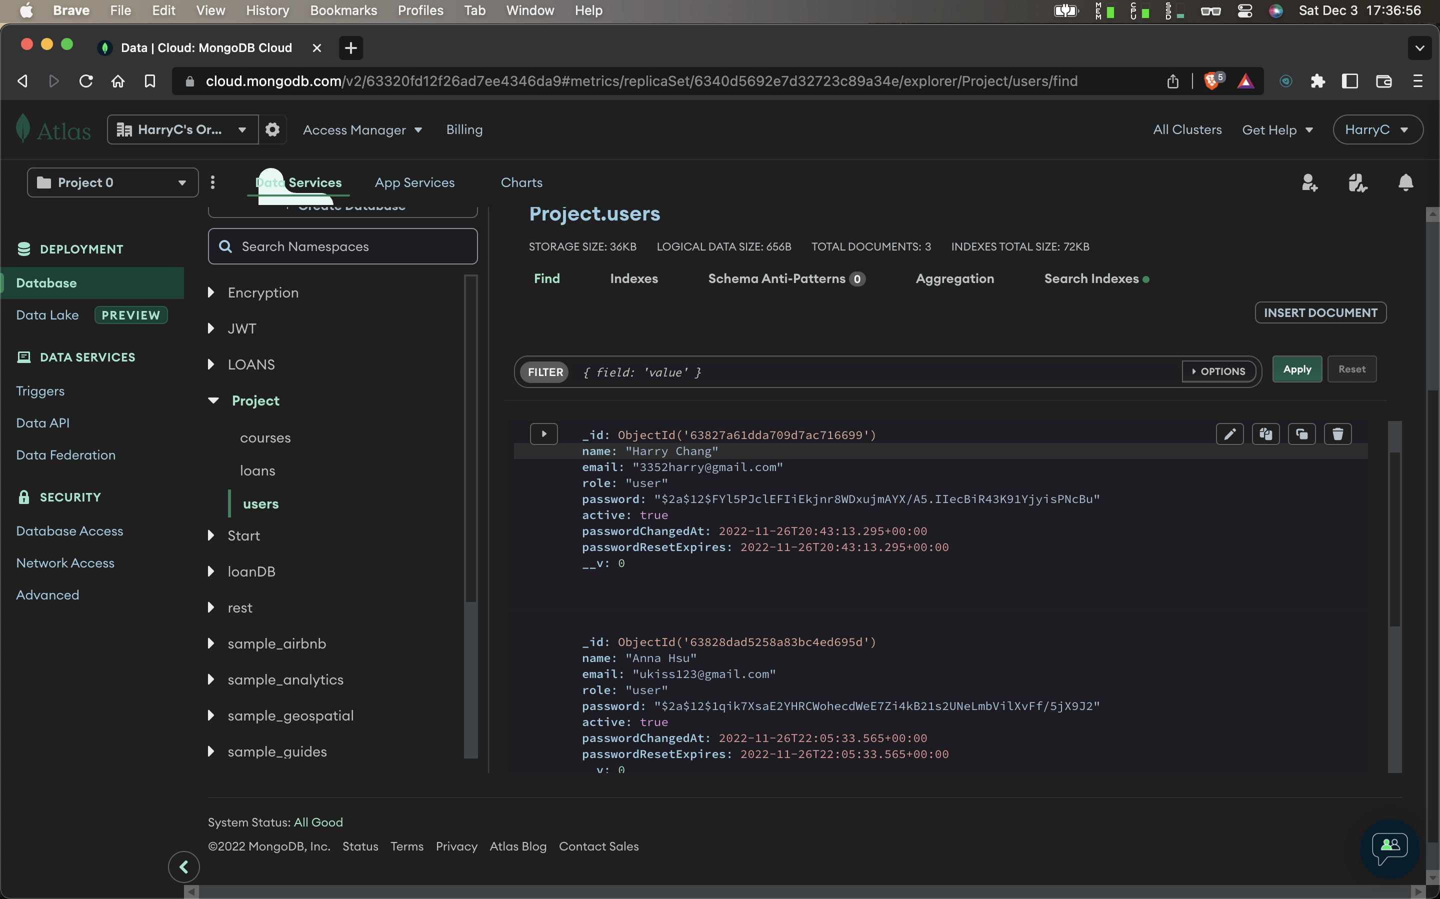

## LoanDataBase

loanModel.js

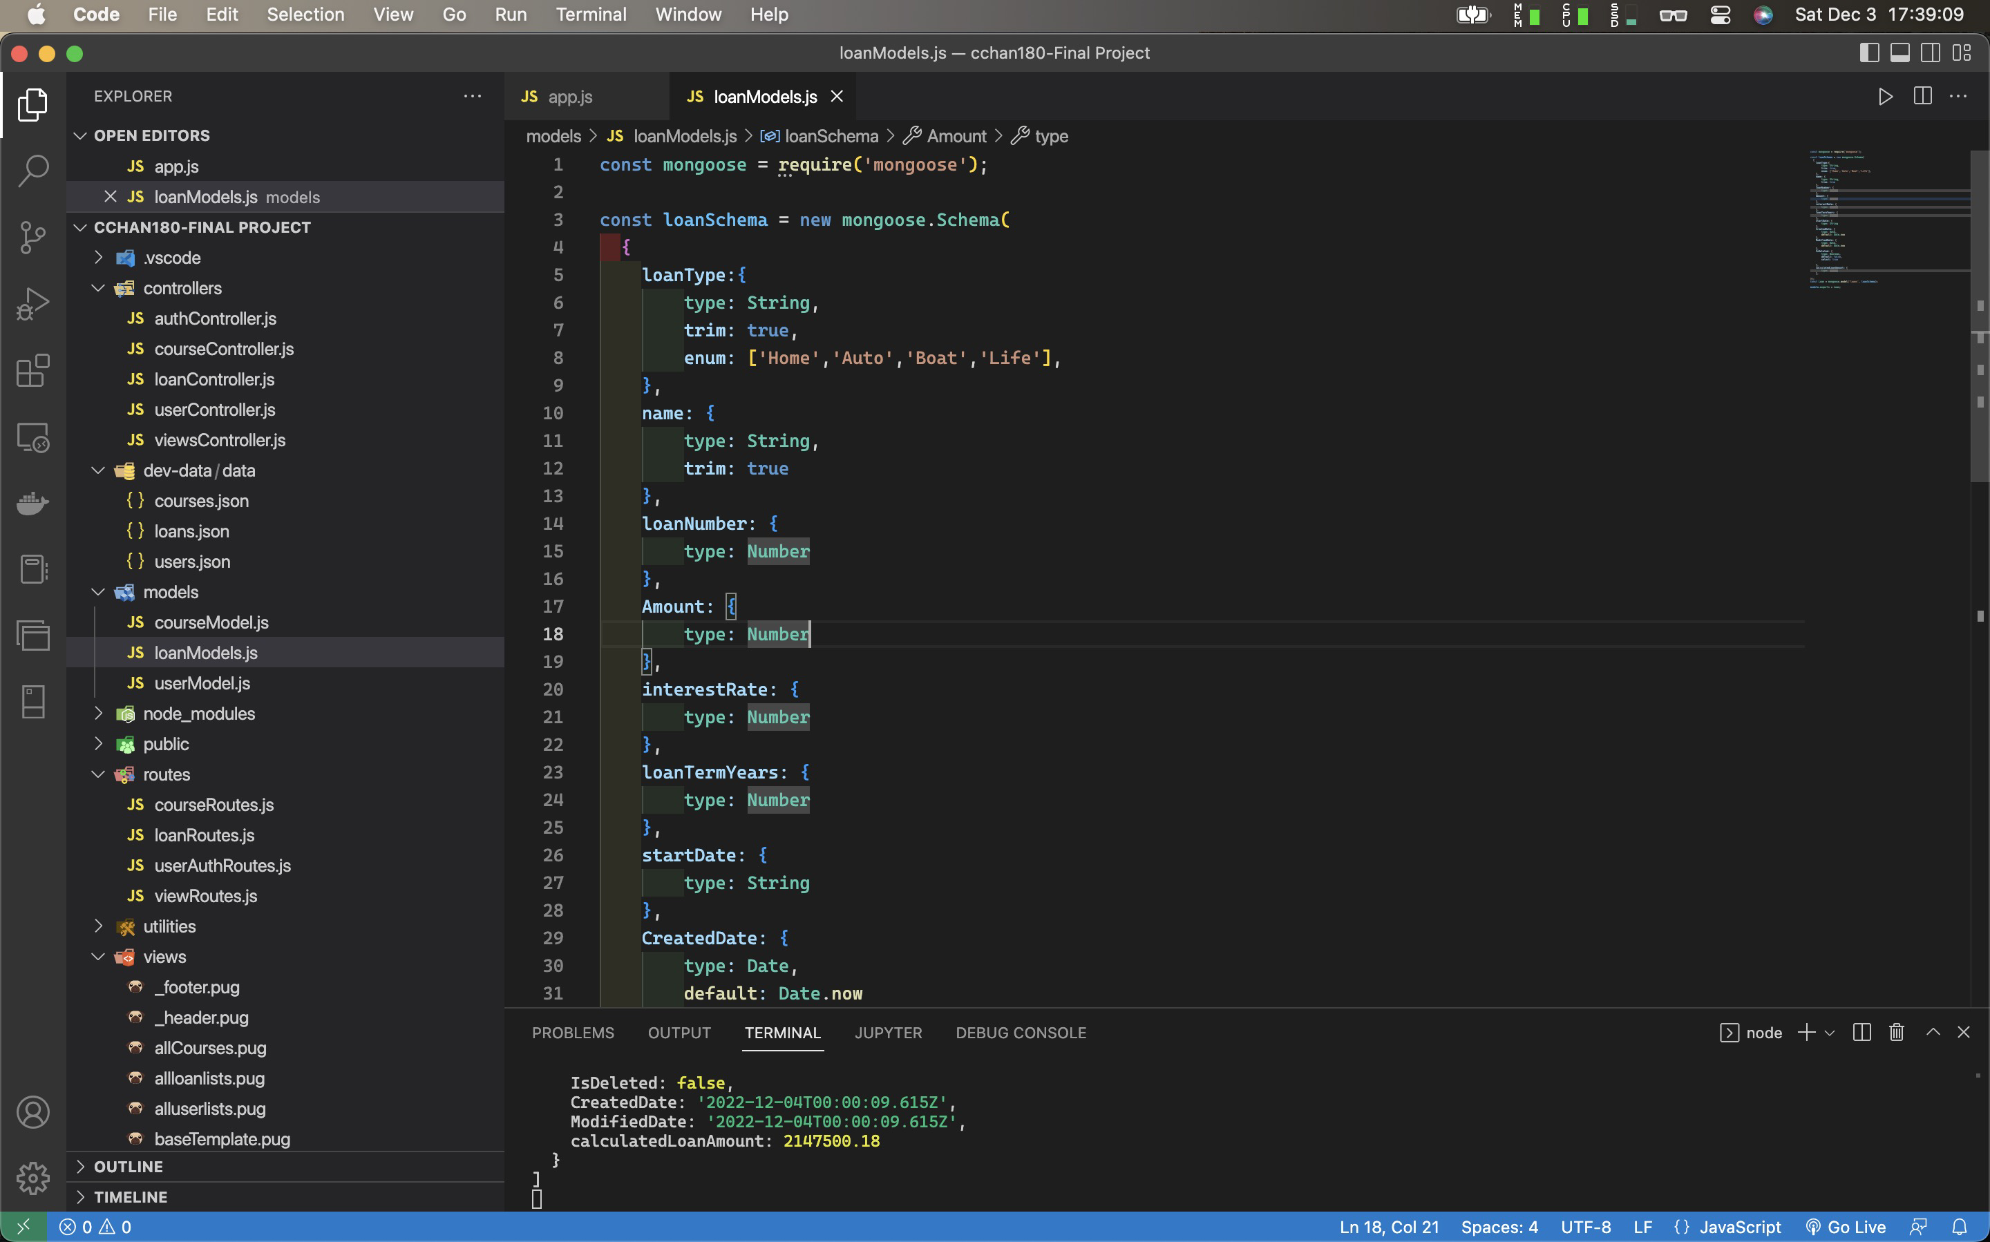

Code of loanModels.js

const mongoose = require('mongoose');

const loanSchema = new mongoose.Schema(

{

loanType:{

type: String,

trim: true,

enum: ['Home','Auto','Boat','Life'],

},

name: {

type: String,

trim: true

},

loanNumber: {

type: Number

},

Amount: {

type: Number

},

interestRate: {

type: Number

},

loanTermYears: {

type: Number

},

startDate: {

type: String

},

CreatedDate: {

type: Date,

default: Date.now

},

ModifiedDate: {

type: Date,

default: Date.now

},

IsDeleted: {

type: Boolean,

default: false,

select: true

},

calculatedLoanAmount: {

type: Number

},

});

const Loan = mongoose.model('loans', loanSchema);

module.exports = Loan;

## LoanCollections

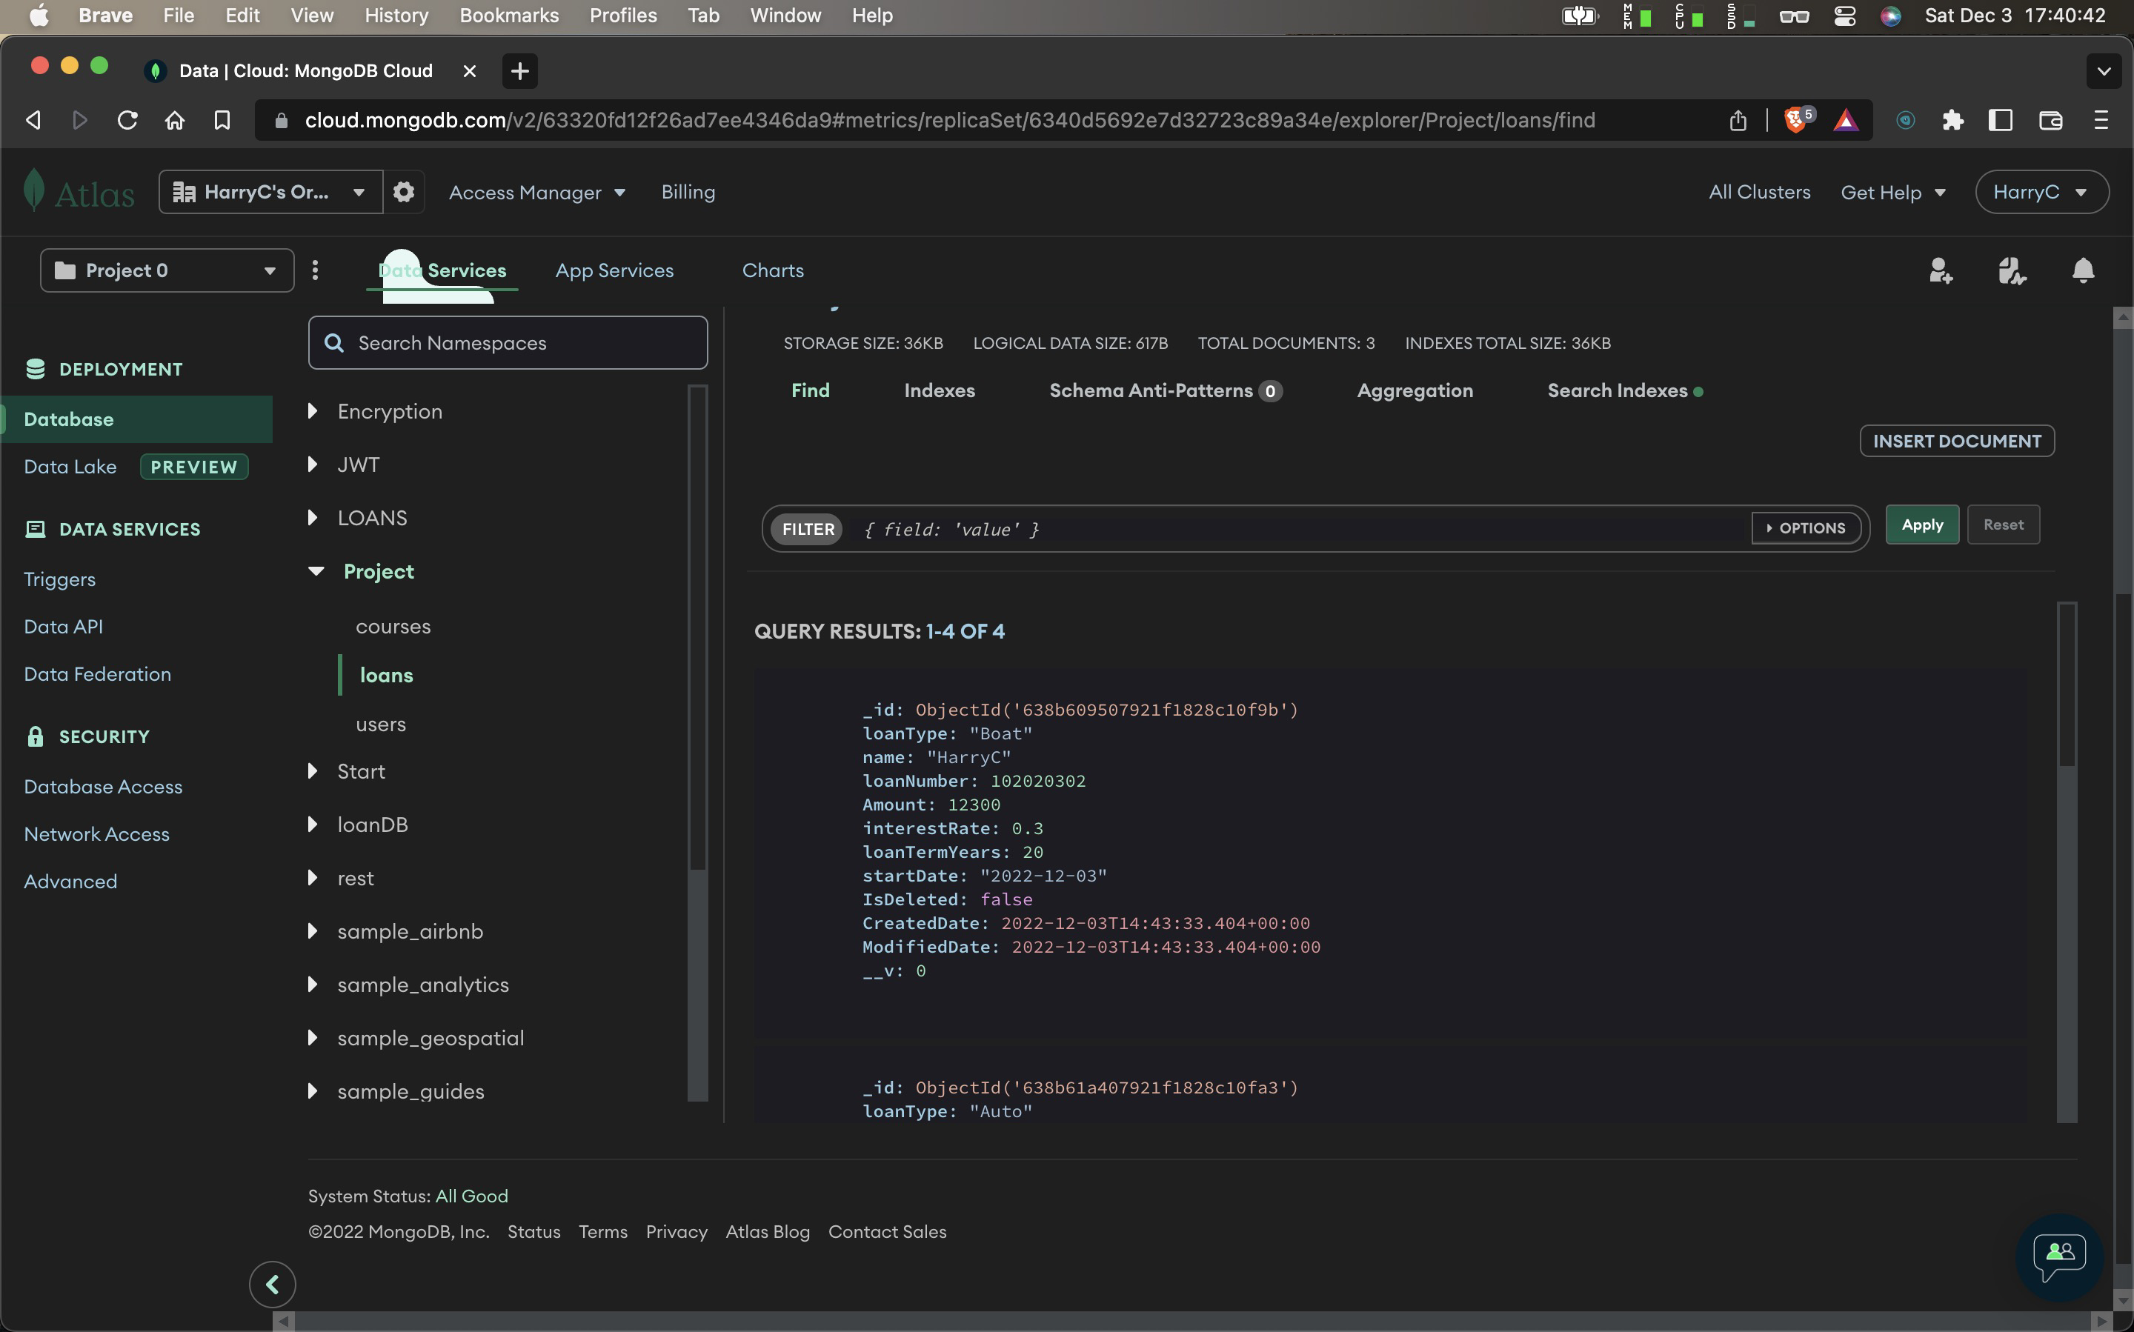

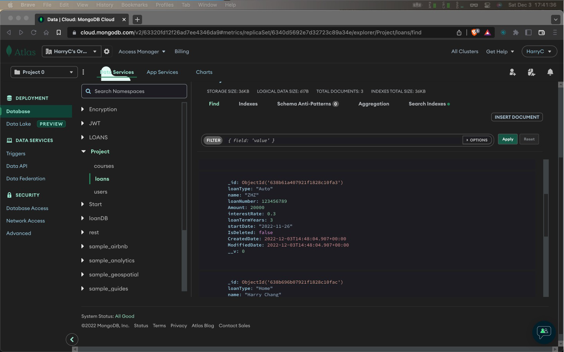

Postman Test:

Create new user

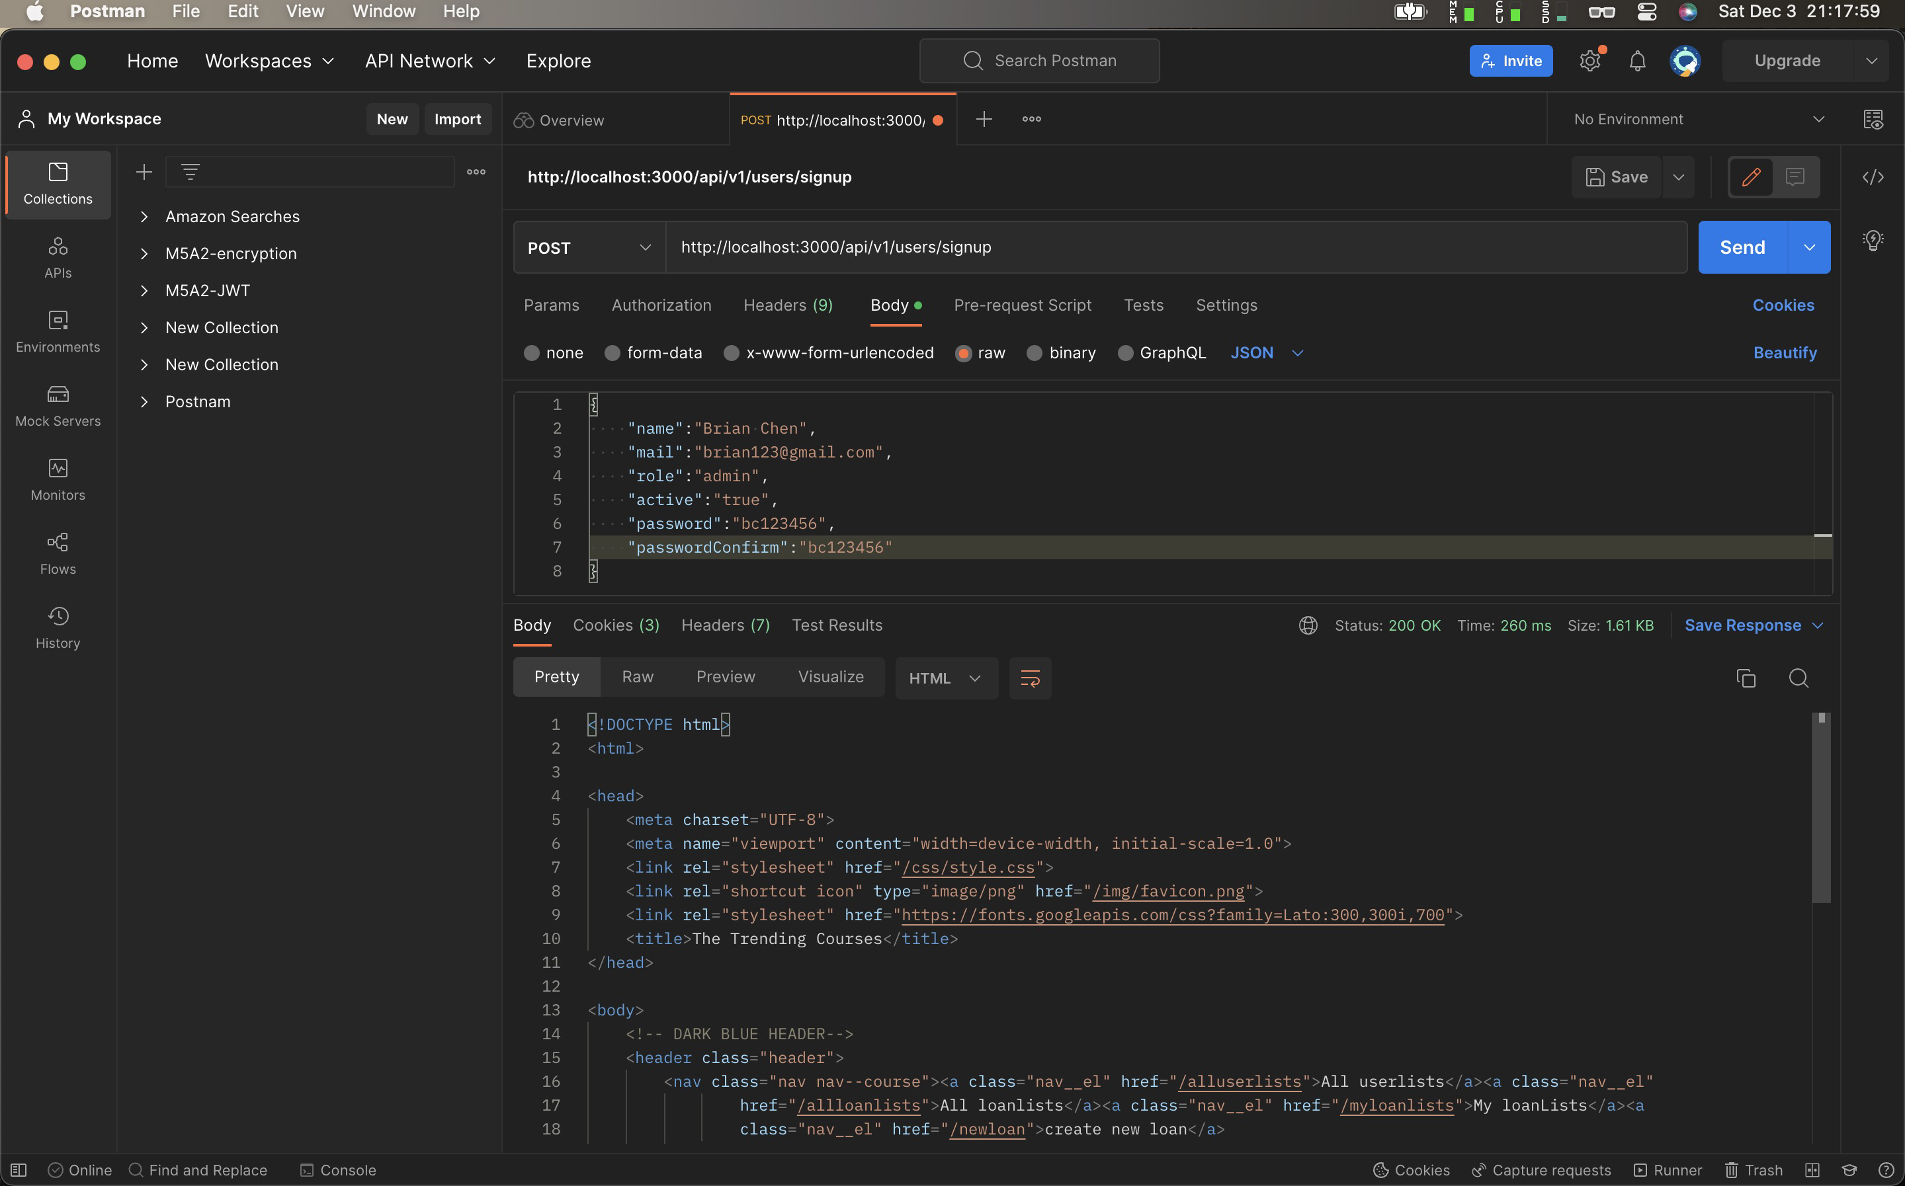

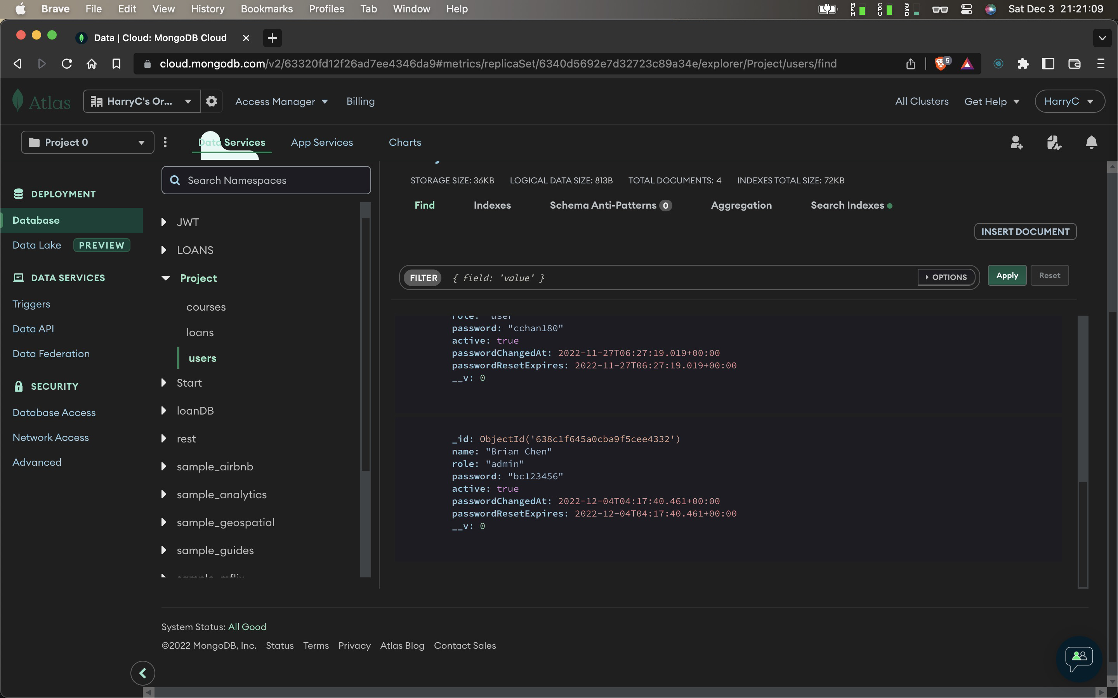

Create new loan

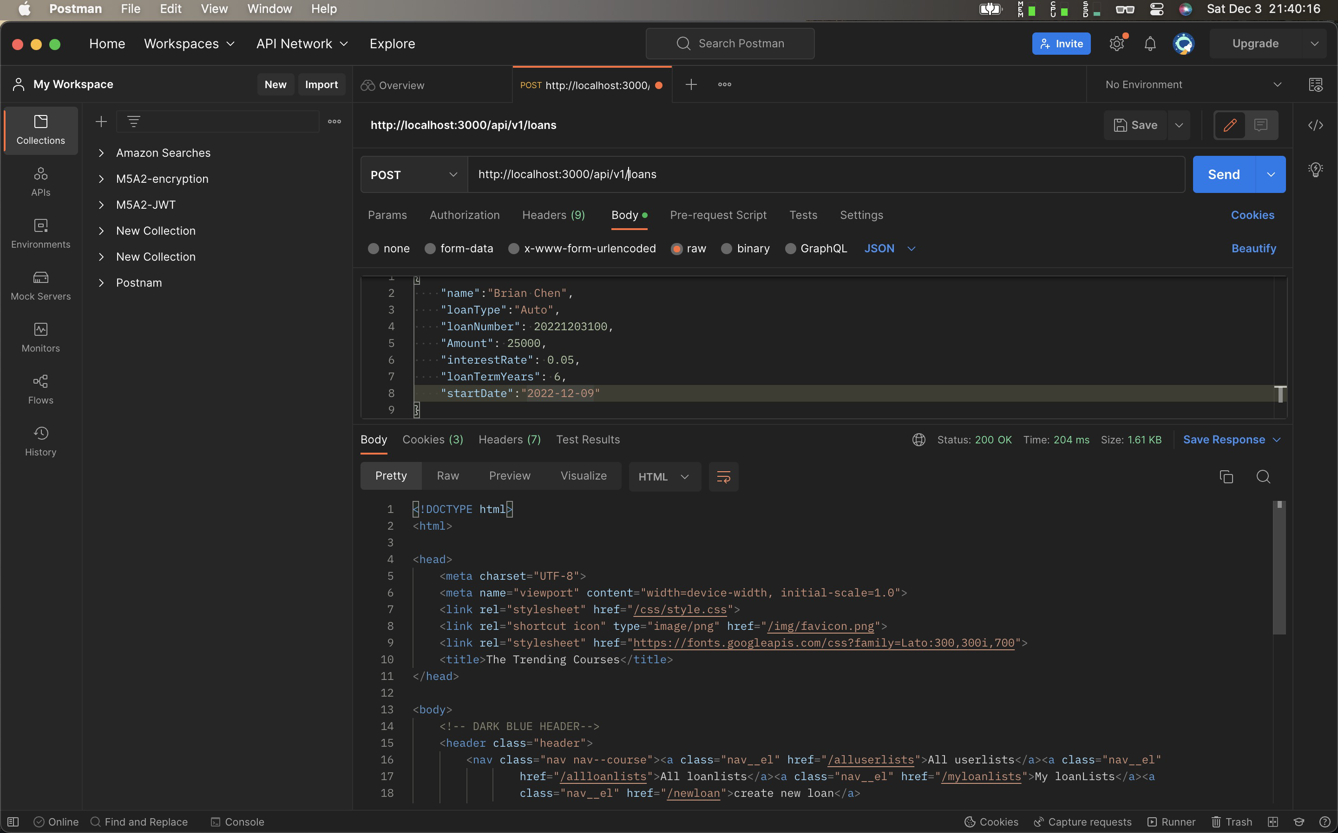

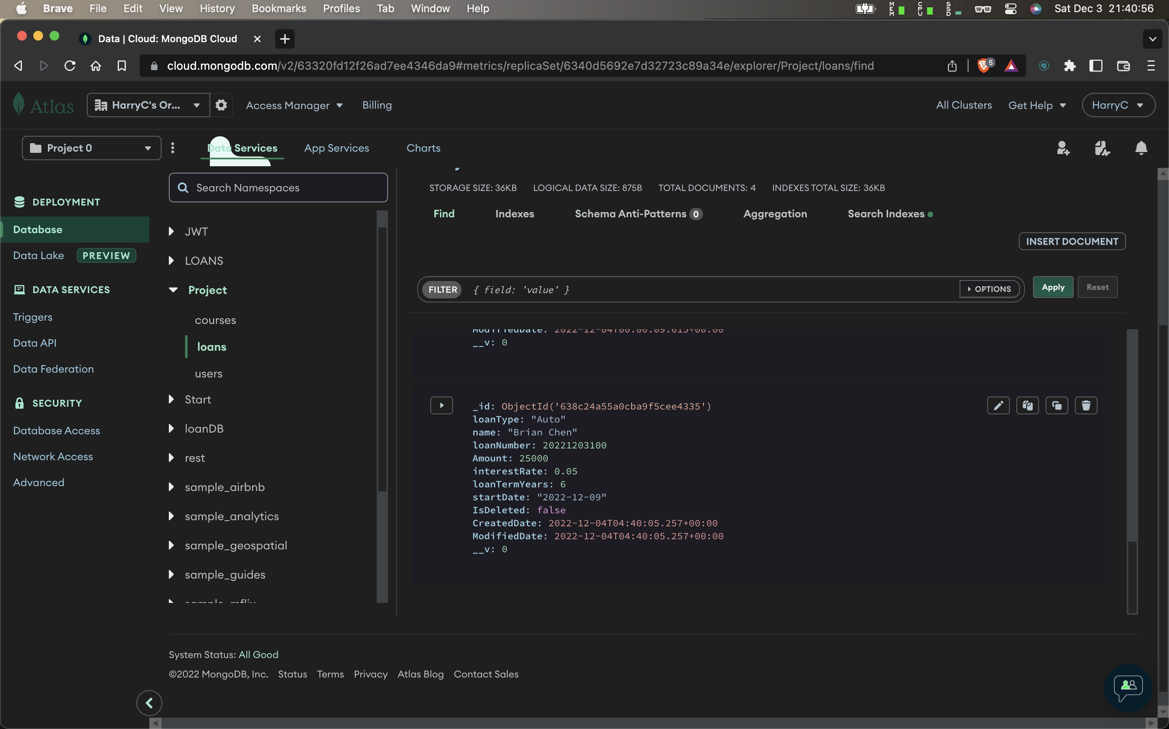

# Run project screenshot

Sign up a user:

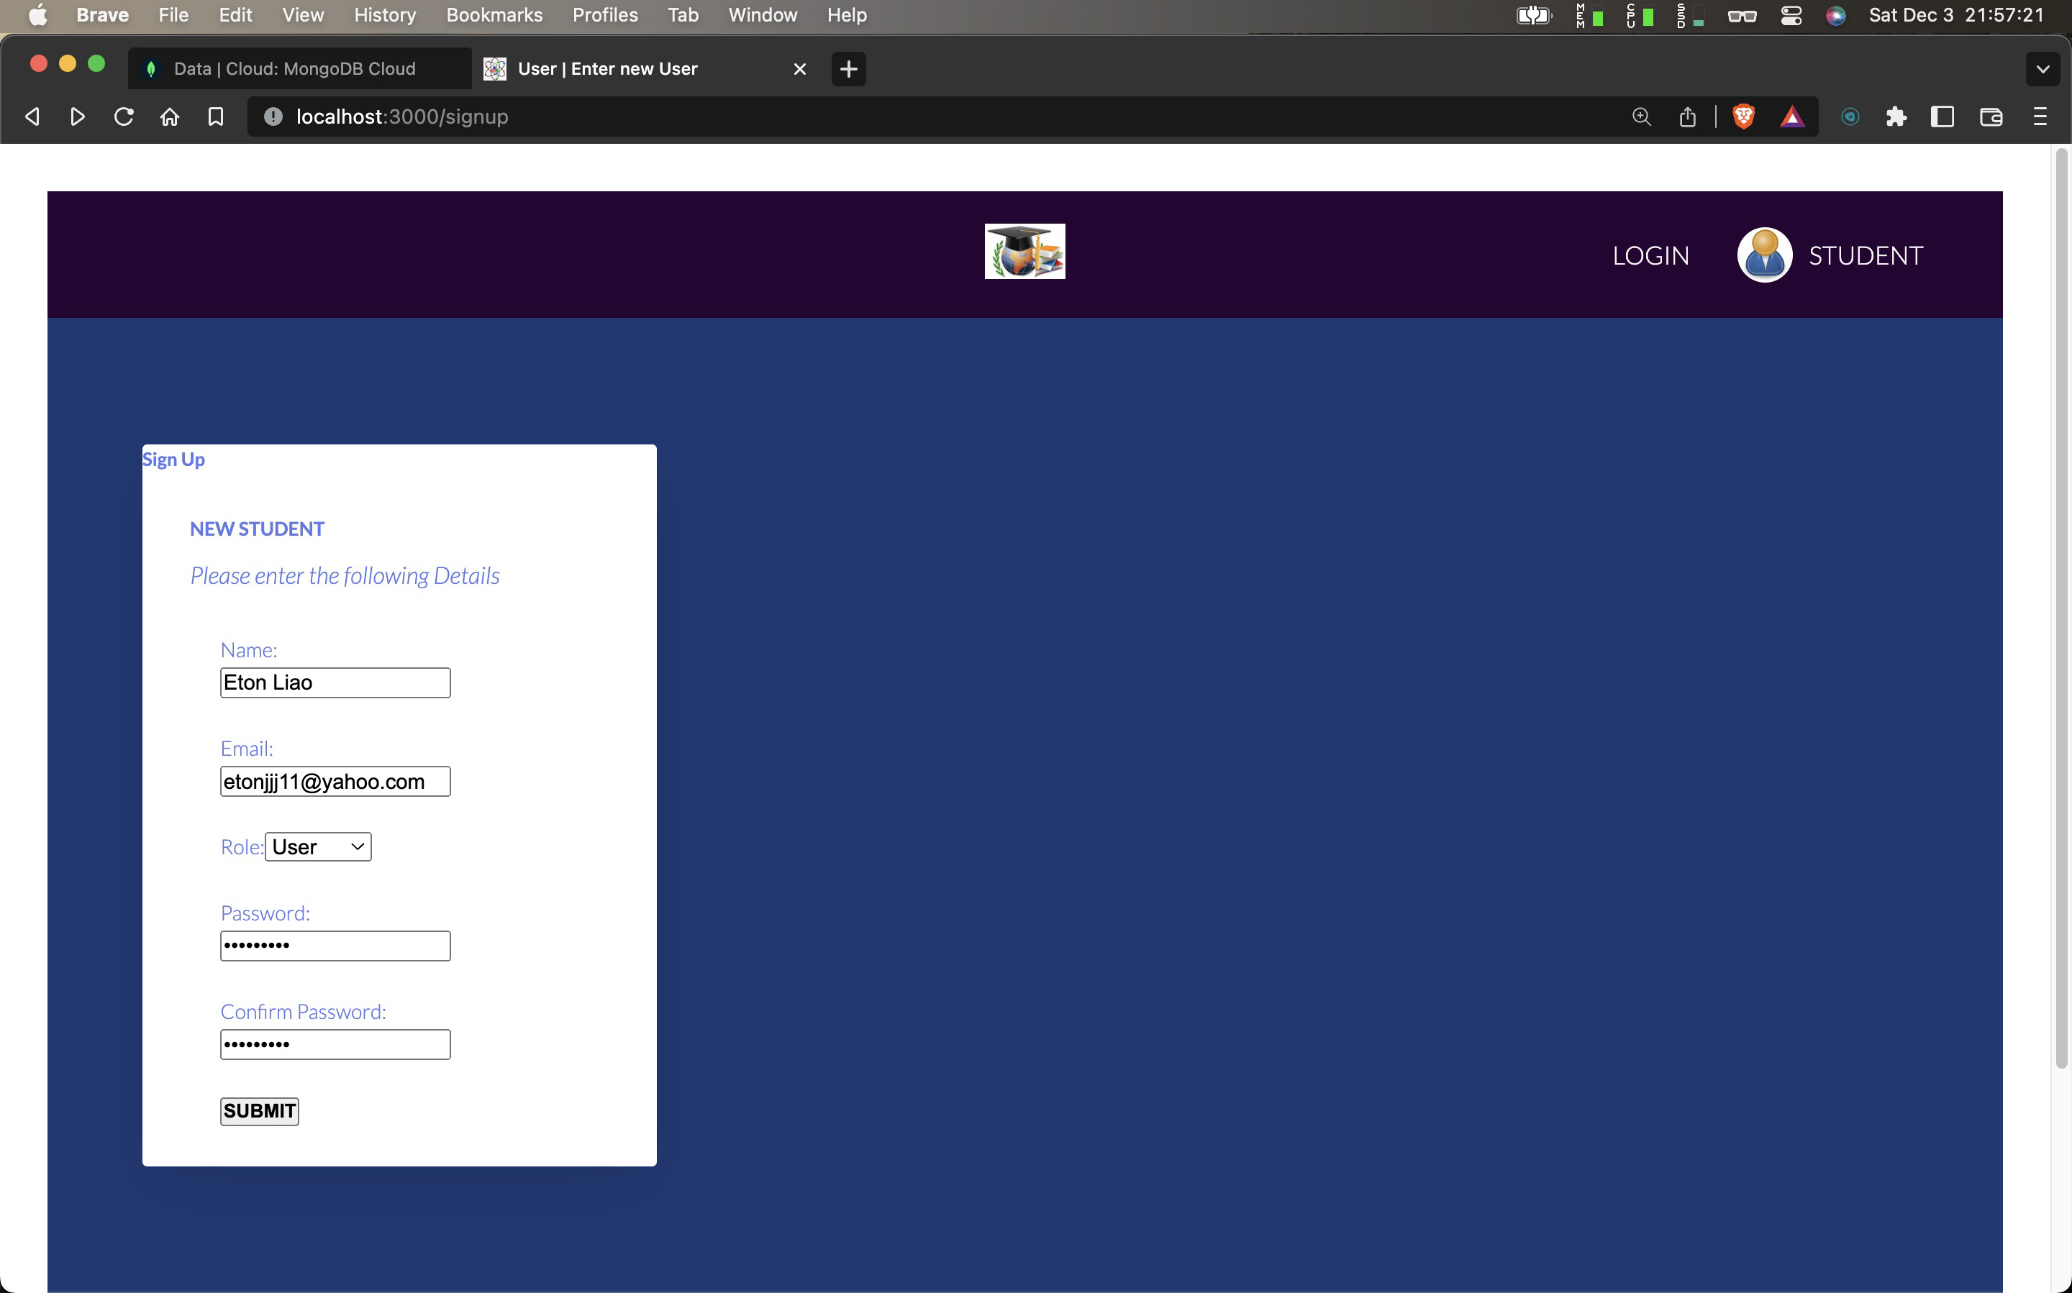

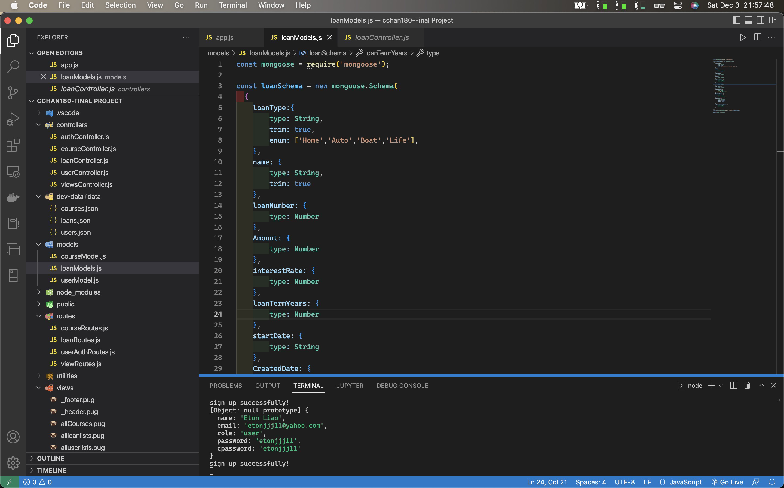

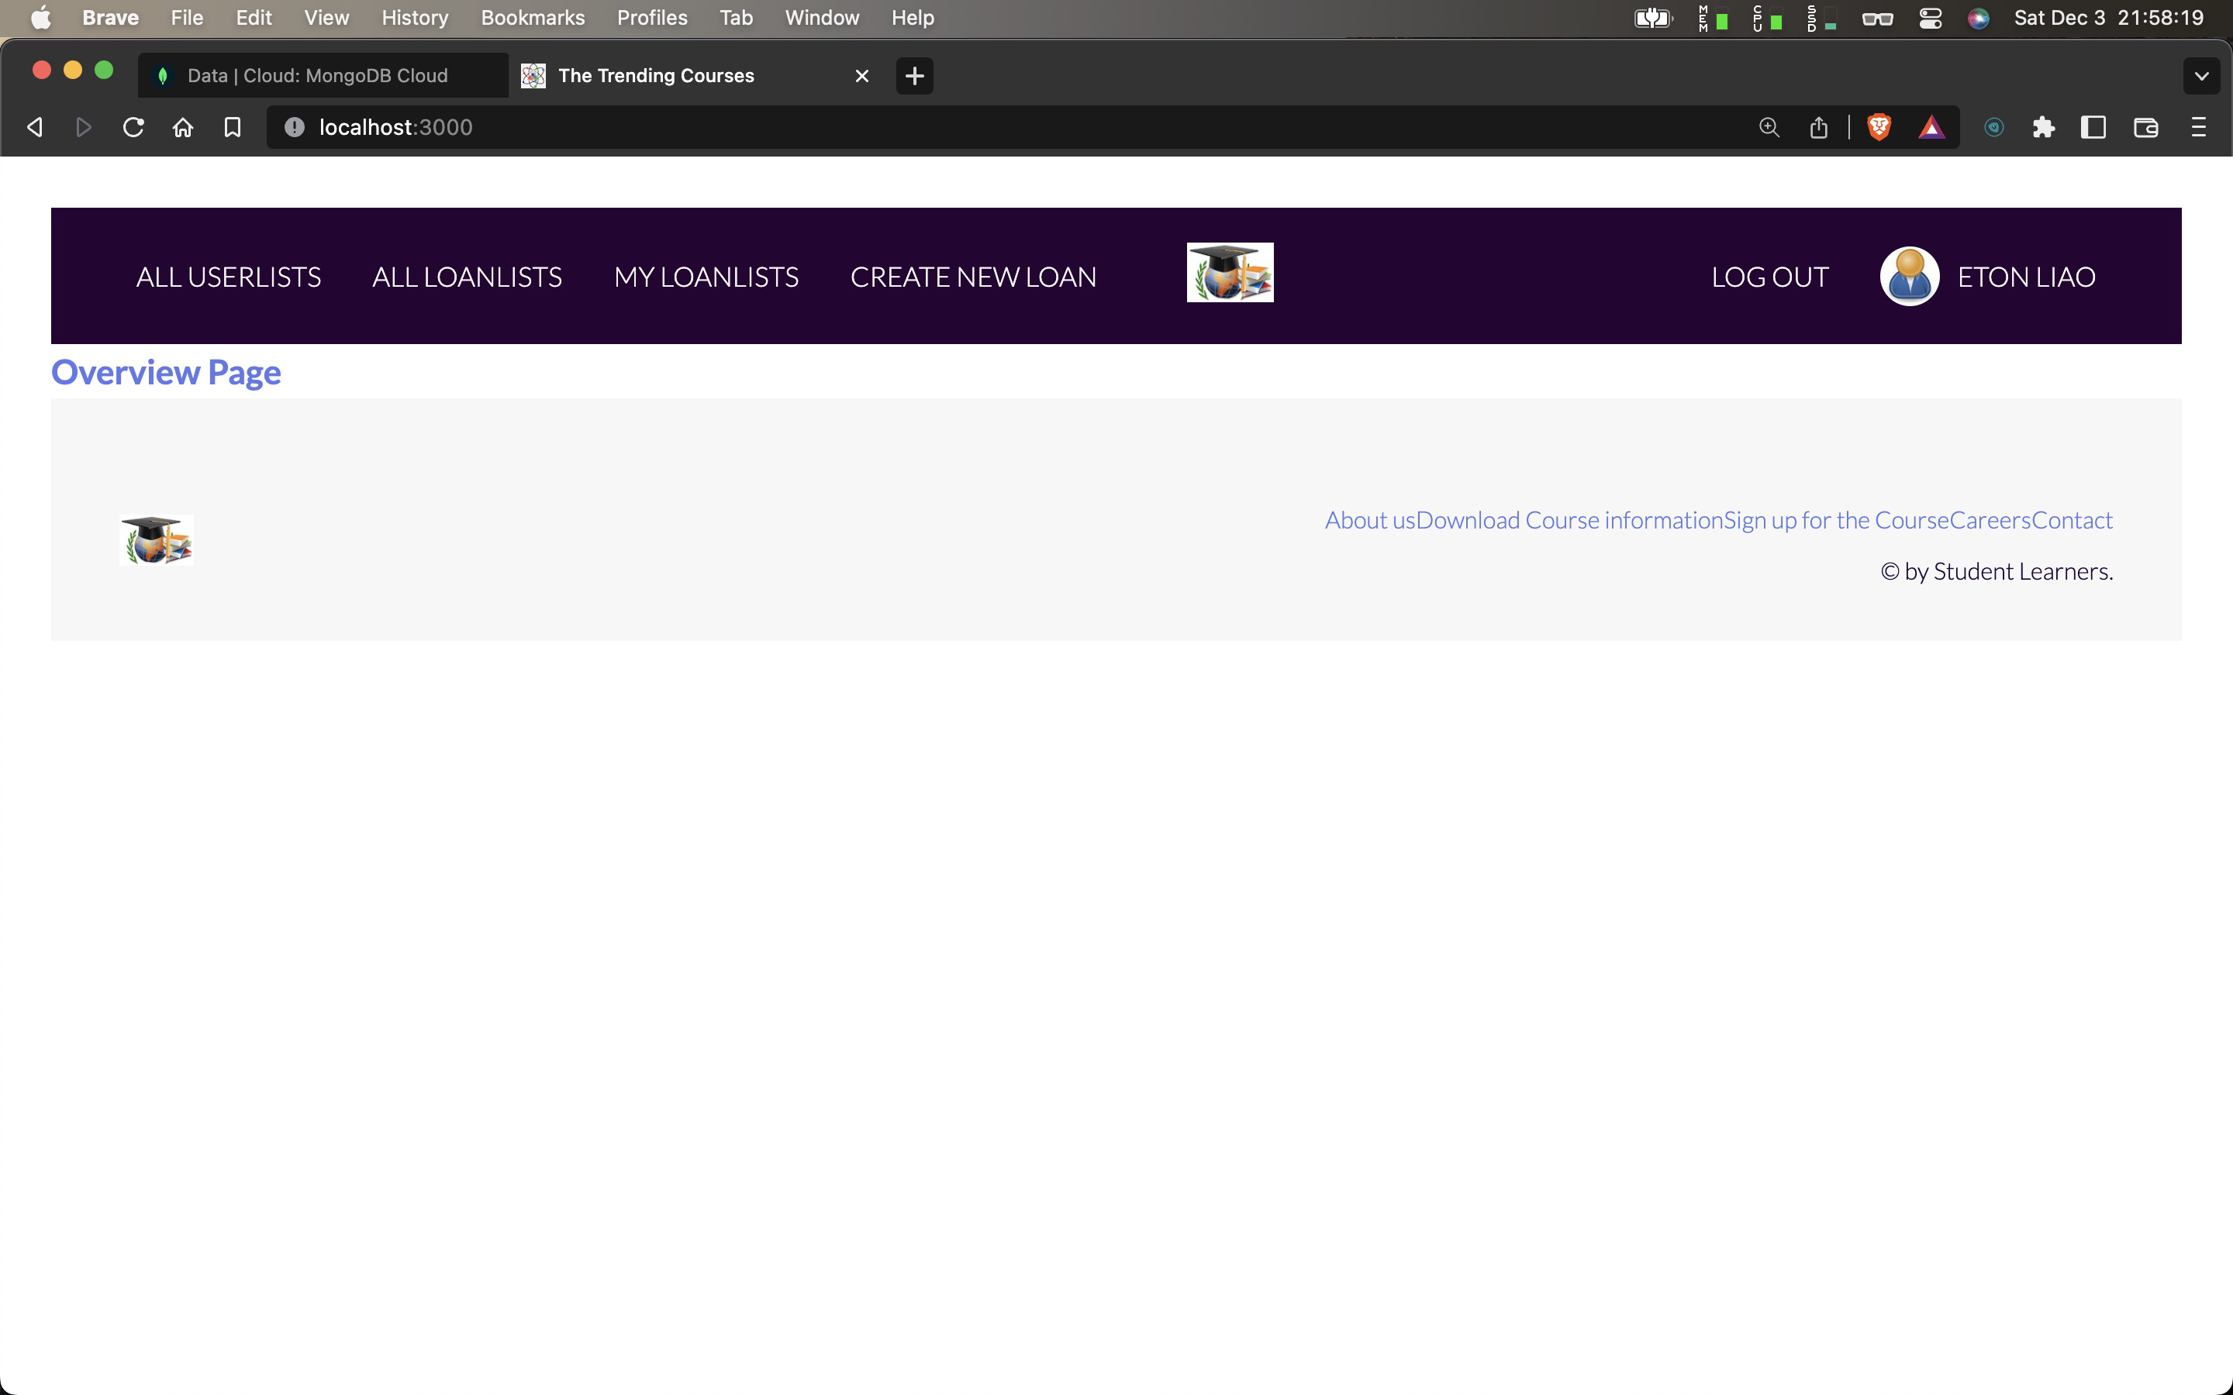

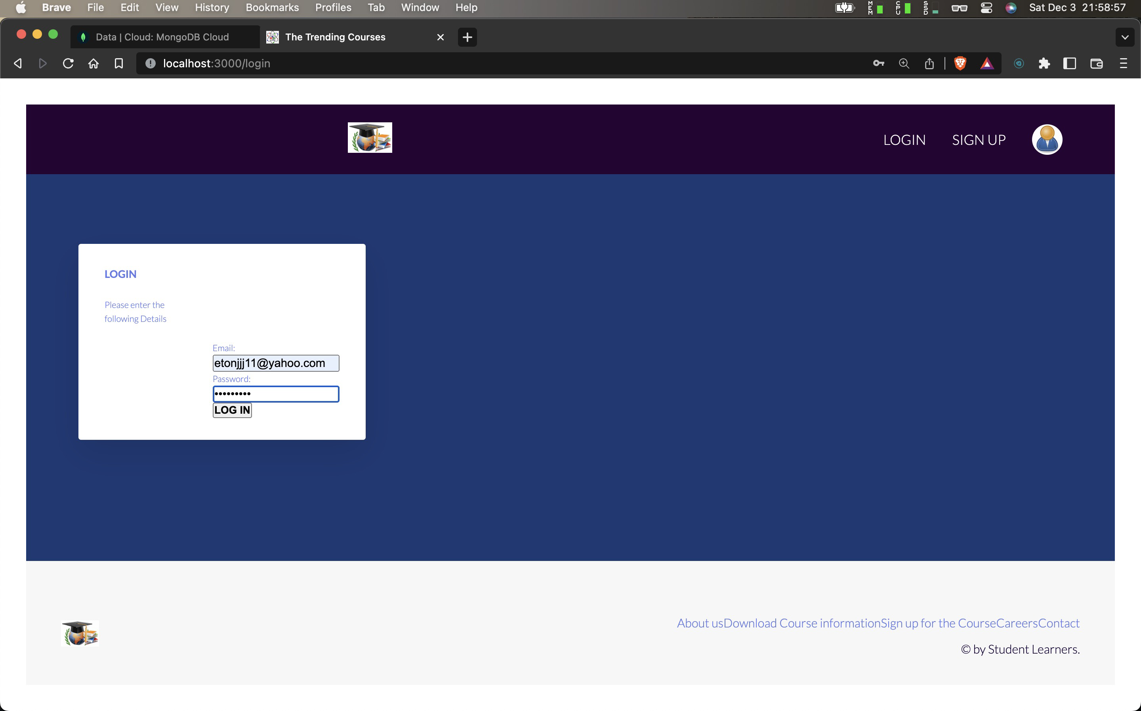

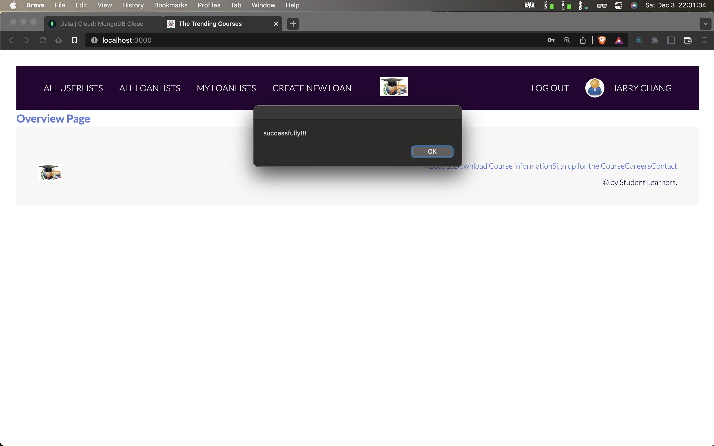

Create a new loan

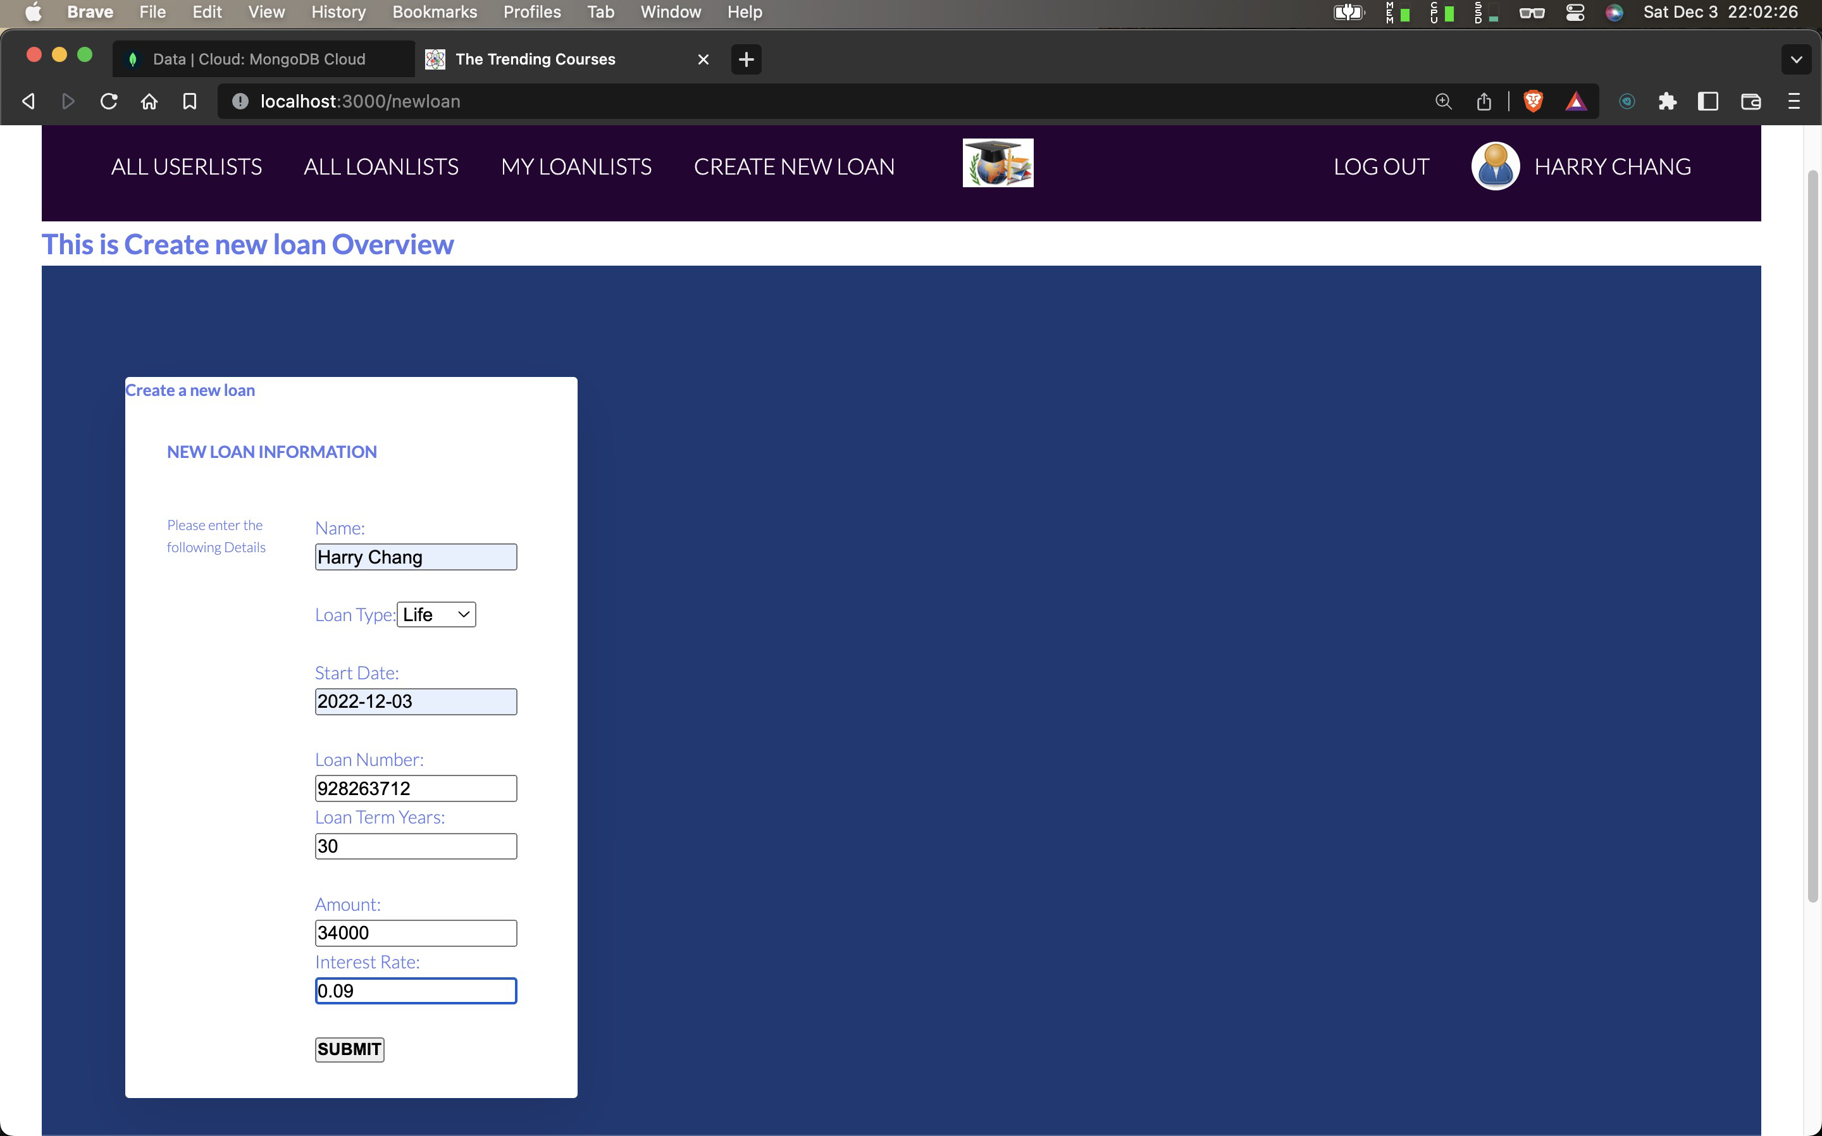

Check my loan lists

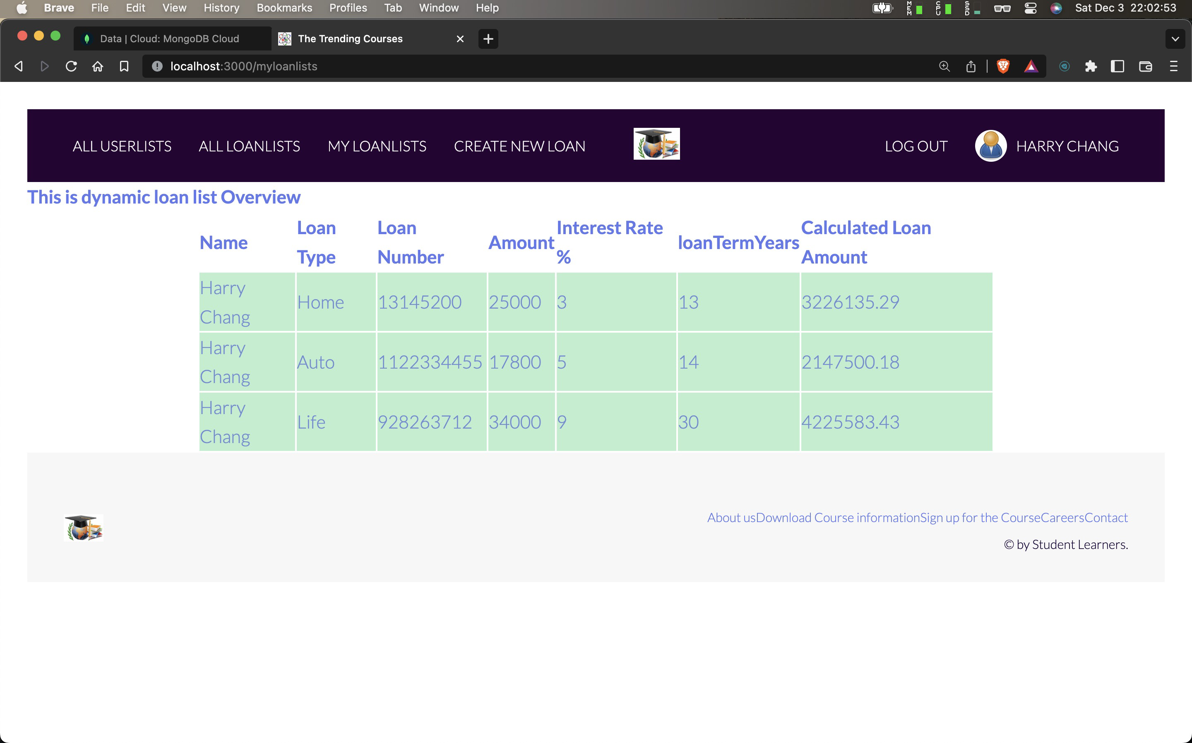

Check all loan lists

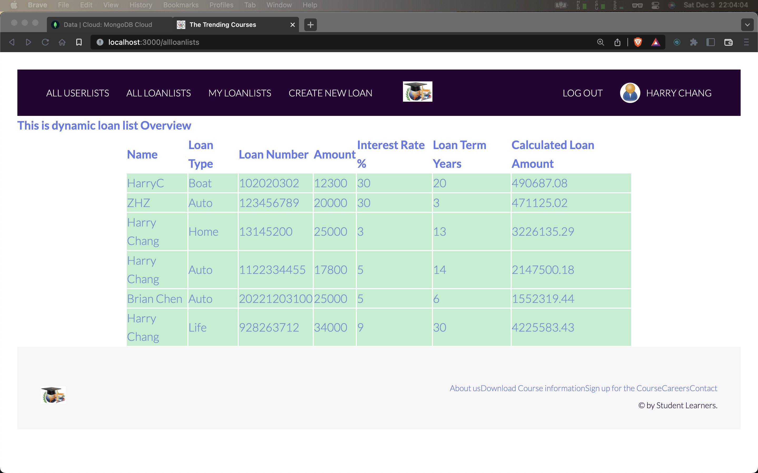

Logout

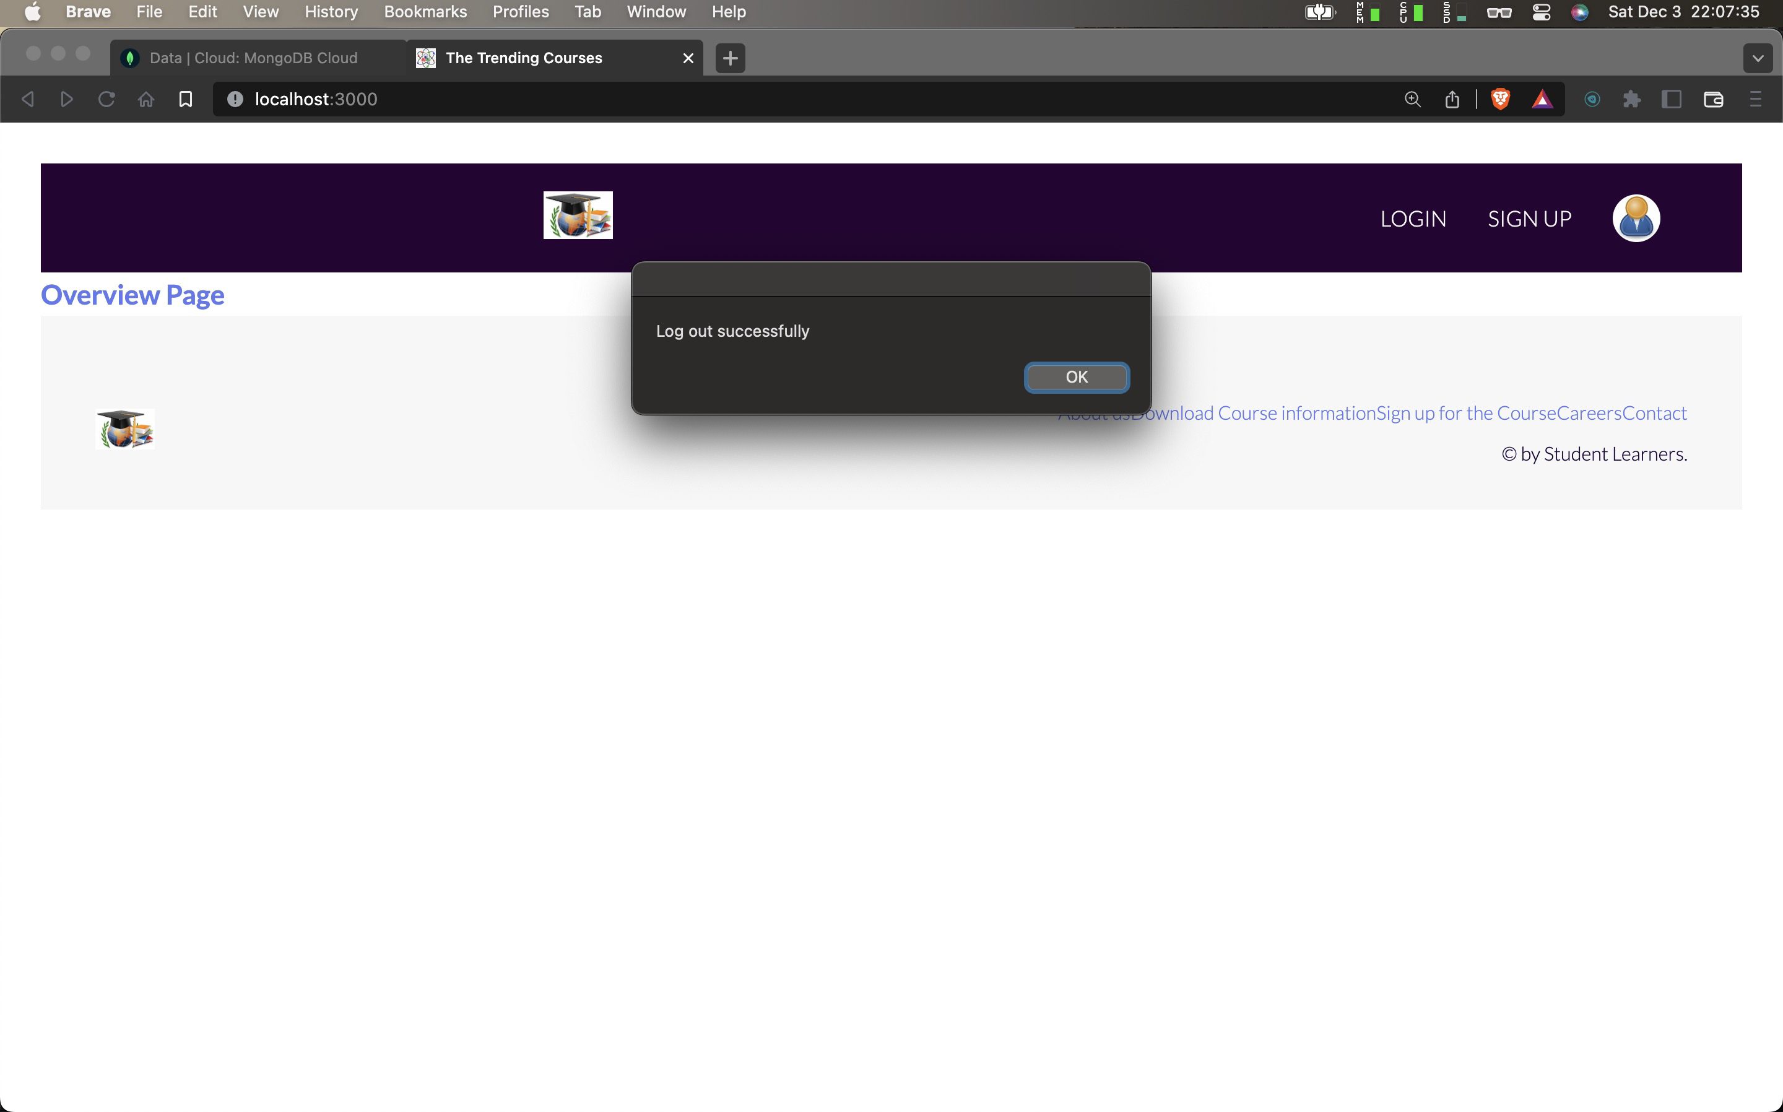

Terminal console

